The John Gann House Mableton, Georgia

Mableton, 1950s. Home of state senator John Gann Built ca. 1842. See also Bicentennial History of South Cobb County in Archives Room, Marietta Library. Home of State Senator John Gann, who represented Cobb County in 1842, just west of the Concord Covered Bridge over Nickajack Creek, and south of the battlefield where the Battle of Ruff's Mill took place on July 4, 1864. The home was spared because a Masonic apron was found in the attic.--from field notes

Cobb County's first State Senator, John Gann, built the Gann House just west of Nickajack Creek on present-day Concord Road in 1841. It is the oldest remaining building in the Smyrna area.
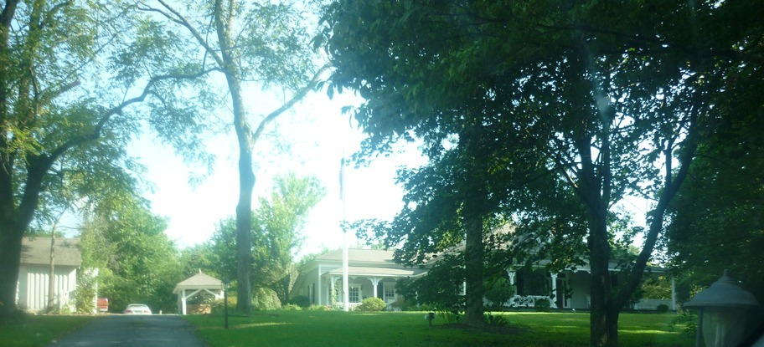

So, why the name Nickajack?
"The name is clearly a Cherokee Indian word," said Doug Davis, local historian and attorney. "Maybe there was a Chief Nickajack or remnants from the Nickajack tribe but without written records at the time, it's nearly impossible to know."
Davis can trace his roots in Cobb County back to 1835. His ancestor, Cobb County's first State Senator, John Gann, built the Gann House west of Nickajack Creek on present-day Concord Road.
The name appears in an early letter from Hugh Montgomery, a U.S. agent to the Cherokees, to then Georgia Governor William Rabun in 1818. The agent references Nickajack — a network of tribal villages scattered across the mountains of present-day eastern Tennessee and northwest Alabama — while on a journey to establish Georgia's northern boundary line with the Cherokee Nation.
But that's quite a distance from present-day Cobb County.
This area north and west of the Chattahoochee River had long been a border region between the Cherokee and Creek nations.
"Normally, Indian border areas would sway about 50 miles either way," Davis said. "By the 1830s, though, the majority of the Cherokee in this area had already left."
After 1832 Georgia Land and Gold Lotteries, lotteries in which whites could "win" land once owned by Cherokees, white settlers and surveyors began subdividing the once-massive Cherokee County and staking their claims. Many believe this is the time the area got its name from a Cherokee chief remaining in this area.
"Nickajack lived in the Smyrna/Mableton area in the early 1830s," Smith wrote in an e-mail. "I can't remember the land lot numbers but it was in the area of Hurt Road and Harris Road near the G. B. Lake."
Brenda McMurray, the bookkeeper of Nickajack Elementary School, recalled Smith's explanation from what she had heard at the time of the school's opening.
"The land where the school is now was in dispute by two tribes," McMurray﻿ said. "Instead of fighting each other, a ball game was played and the winning tribe won the land. The losing team/tribe had to move."
Regardless of how it came to be, the name Nickajack Creek next appears on an 1839 map with the stream converging with the Chattahoochee south and west of the Standing Peach Tree settlement.
About this same time, a Nickajack community sprung up alongside the creek and Concord Road in the mid 1800s, said Mandy Elliott, a planner with the Cobb County Community Development Agency.
In the preservation plan of the Concord Bridge/Ruff's Mill Historic Area that Elliot submitted, the first white settlement on the creek was called Mill Grove, later appearing as Nickajack.
While the names and owners changed over the years, the legacy of the Nickajack name remains across South Cobb.
"You can read history books all you want, but it's these local histories where you truly feel the connection," Davis said.

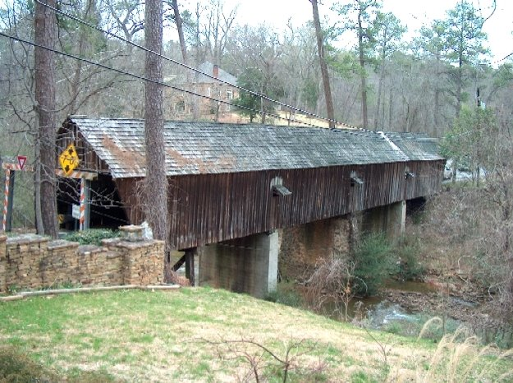
The Concord Covered Bridge, which crosses over Nickajack Creek, was originally built c 1848 - 1850. During the Civil War, on July 4, 1864, Union soldiers burned it, along with the Concord Woolen Mill, downstream, that made Confederate uniforms. The ruins of the mill are now a part of Cobb County's Heritage Park.
The Concord bridge was rebuilt in 1872 by Robert Daniell and Martin L. Ruff, measuring 16 feet wide and 131.7 in length. It still serves the public very well. The mill was also rebuilt after the war but it went out of business in 1916.
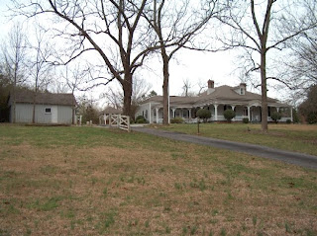
After you pass through the Covered Bridge, continuing on Concord Rd., on the left you will see a large white house that sits on a small hill. This house was built around the year 1841 for John Gann, Cobb County's first State Senator. I didn't know very much about the Gann's so I did a little research. I was surprised to find that Agnes Barnes, mother of former Governor, Roy Barnes once lived there. Then again, I'm not, because the Barnes family reside in and around Smyrna-Mableton area. The house originally sat on 380 acres of land - and a lot of drama has happened to both the occupants and the house over the years. Here is a good read on the Gann's, The Reconstruction of an Amazing House. According to the Smyrna Historical Society, it is the oldest building in Smyrna.
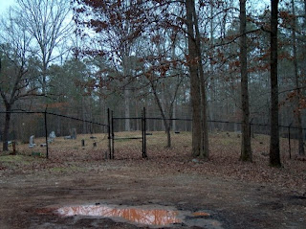After leaving the Gann House, if you continue on Concord Rd., you will soon see South Hurt Rd. on the right. Turn onto South Hurt Rd. and take the next road to the right, which will be Fowler Rd. Follow the road until it dead ends - here you will find the Gann Cemetery. I was shocked. The cemetery is almost completely destroyed. Tombstones are tumbled and broken. Graves look like they have been half way dug-up. If you walk in the front gate, John Gann's grave is straight ahead, at the back of the cemetery. The top of his tombstone is lying on the ground behind the base. A friend of mine said that it looks like some work has been going on there, that at one time many things were spray-painted. This is sad.
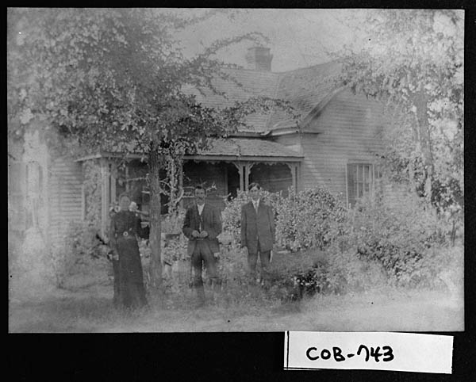

Type: | Photographs
Title: | [Photograph of Thomas Benton Dodgen home, Mableton, Cobb County, Georgia, ca. 1908]
Date: | 1908
Description: | "Cobb County, ca. 1908. Floyd Road at Moss (now Center) Street. Thomas Benton Dodgen home. Left to right: Narcissus Jenn Dodgen, Thomas Benton Dodgen, their son Louis A. Dodgen.  Mableton, Cobb County, Georgia, home of Thomas Benron Dodgen, on Floyd Road at Moss (now Center) Street, built in 1889. He, his son Louis A. Dodgen, and his wife, Narcissus Gan Dodgen, are in the picture, she being youngest daughter of State Senator John Gann, who represented Cobb County in 1842 when the State Capitol was in Milledgville.  T.B. Dodgen owned and operated a general store in Mableton, on Front Avenue, around the turn of the century, which he sold to M.A.J. Landers.  Narcissus Gann was born in the John Gann home near the covered bridge the Dodgen family, refugeed to Monroe, Ga., during the War Between the States, and upon returning home following the Battle of Ruff's Mill, she rode horseback, as a teen age girl, to Lithia Springs to borrow garden seed to plant a garden.  Louis A. Dodgen was 91 years of age March 8, 1980.  Thomas Benton Dodgen was a son of John Lenoard and Elizabeth Goodson Dodgen, who owned and operated Dodgen Mill on Nickajack Creek before and after the War Between the States."--from field notes

