THOMAS LLOYD GANN
OBITUARY
(Marietta Daily Journal - 27 NOV 1924)
FLOYD
Mr. Loyd Gann
Our community was saddened Friday morning when the death angel bore the spirit of Mr. Loyd Gann away. Mr. Gann had been sick for quite awhile, but bore his suffering with great Christian fortitude.
He joined the Concord Baptist Church when quite a young boy. He was amen of splendid character. His big heart and gentle manner won many friends for him. His funeral was held in the Concord church Saturday morning at eleven o’clock, Rev Geo. Crow conducting the services. Mrs. E.P. Williams sang “In the Garden” and “Asleep in Jesus.” The floral offerings were beautiful and showed the esteem in which he was held by those who knew him best. Interment took place at Mableton.
Mr. Gann leaves a wife and two children a mother, two sisters, and two brothers, and also a number of other relatives.
Messrs. Mayfield, Moor, Hicks, of the Southern Bell Telephone Co., attended the funeral of Mr. Gann Saturday.
(Marietta Daily Journal, 27 NOV 1924—Trans. 9/15/09 ALP3)

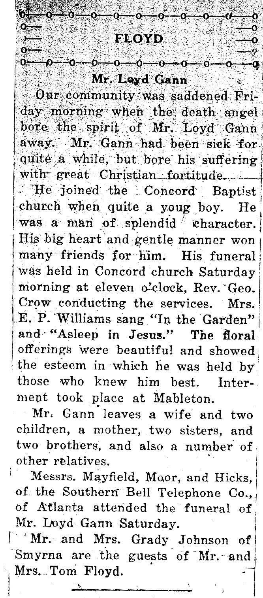
NOTES: Thomas Lloyd Gann, 1893-1924; son of Oliver David Gann, 1860-1921 and Mary Elizabeth Collier 1858-1942. Wife: Nell Phinizy Park, 1899-1968. Buried Davis Baptist Chapel Cemetery; Austell, Cobb, Georgia

