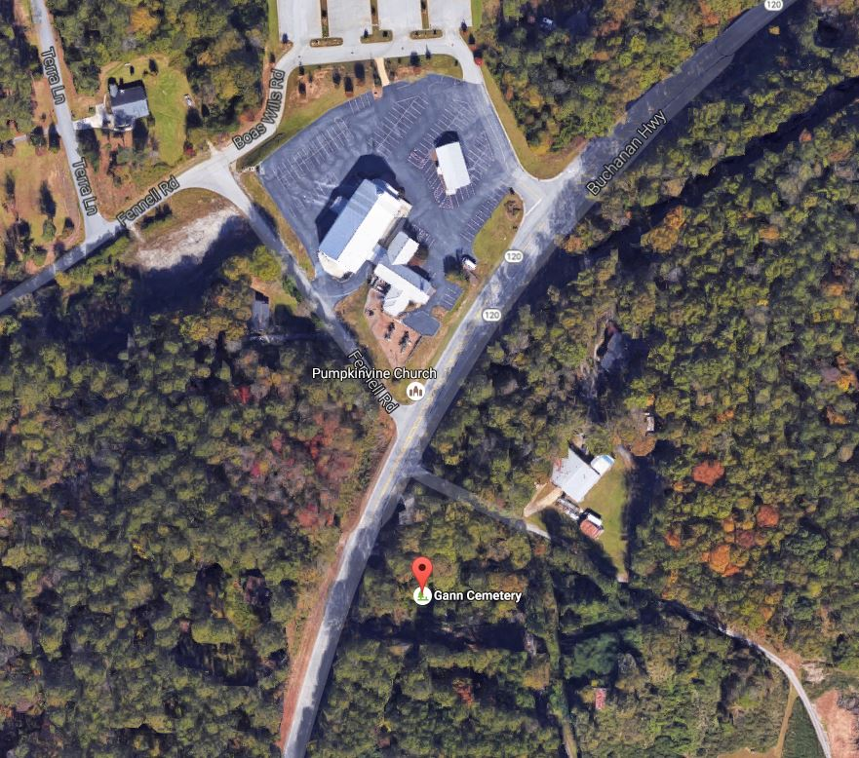
GANN FAMILY CEMETERY, Paulding County, GA
Copyright. All rights reserved.
http://www.usgwarchives.net/copyright.htm

Georgia Table of Contents: http://www.usgwarchives.net/ga/gafiles.htm

Compiled and Submitted by:
Judy and Chuck Cronen and Lucille Buter FISHTOG@aol.com

GANN FAMILY CEMETERY, Paulding County, GA

Information:
This was a family Cemetery at one time but is now
used by and maintained by the Pumpkinvine Baptist
Church which is just down the road. To get to the
Cemetery from Dallas, take Highway 120 (Buchanan
Highway) towards Buchanan. Look for Gann Cemetery
Road on your left about a mile and 3/4 from Highway
278. The Cemetery will be on your right, just a
short ways down Gann Cemetery Rd.
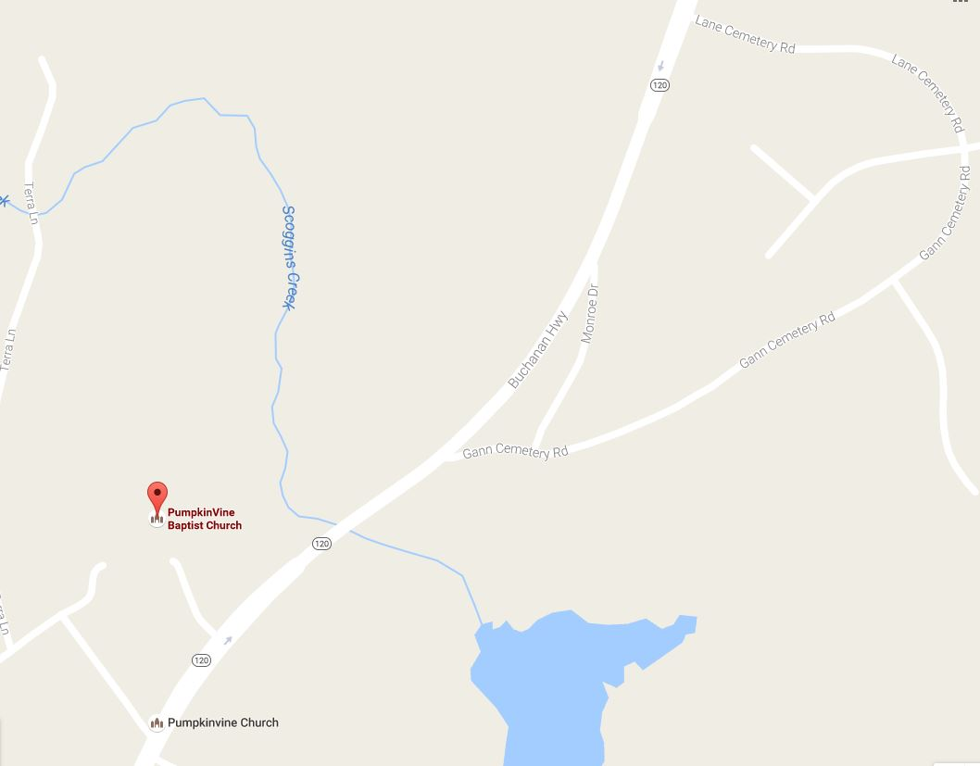

Name Birth Date Death Date Notes

GANN FAMILY CEMETERY, Paulding County, GA

Compiled and Submitted by:
Judy and Chuck Cronen and Lucille Buter

E-mail: FISHTOG@aol.com

Information:
This was a family Cemetery at one time but is now used by and maintained
by the Pumpkinvine Baptist Church which is just down the road.
To get to the Cemetery from Dallas, take Highway 120 (Buchanan Highway)
towards Buchanan. Look for Gann Cemetery Road on your left about
a mile and 3/4 from Highway 278. The Cemetery will be on your right,
just a short ways down Gann Cemetery Rd.

Name Birth Date Death Date Notes

Adair, Albert 2-03-1889 4-18-1889
Adair, Amanda 5-13-1859 5-28-1931
Adair, Bobby 6-01-1891 8-19-1891
Adair, Emma J. 1-07-1873 9-04-1955
Adair, J. H. 2-13-1849 4-30-1918 H/O S. M.
Adair, J. L. 9-30-1860 8-06-1913 H/O M. F.
Adair, James B. 5-18-1823 4-10-1897 CSA,H/O M.E.B.
Adair, Lillah M. 2-06-1884 10-19-1906 W/O S. L.
Adair, M. R. 2-04-1857 1-22-1936
Adair, M. F., Mrs. 3-27-1868 2-13-1936
Adair, Magaret Elizabeth 1838 1917 W/O James B.
Adair, S. L. 3-07-1881 3-14-1975 H/O Lillah
Adair, S. M. 12-11-1858 NO DATES W/O J. H.
Adair, Walter James 1893 1980 US Army, WWII
Barnes, Opal 3-06-1915 10-07-1999 "Mother"
Barnes, Thomas F. 1-10-1955 7-08-1999 "Brother"
Bates, Frankie O'Neal 4-07-1963 9-30-1979
Bone, Bertha Compton 10-19-1888 7-09-1927 W/O Rich
Bone, Emma J. 1887 1918 W/O Pleasant R.
Bone, Francis V. 8-08-1922 1-06-1923 D/O L. B.
Bone, Leola 1-06-1896 9-27-1904 D/O M&M J. M.
Bone, Pleasant R. 1877 1922 H/O Emma J.
Butler, Clyde 7-12-1912 10-15-1962 Tran Corps., WWII
Butler, Elvie C. 8-16-1912 4-29-1993 W/O Harris E.
Butler, Emmett 10-12-1893 5-01-1948
Butler, Eunice H. 10-12-1893 5-01-1948 W/O M. Frank
Butler, Harris E. 2-04-1923 3-01-2003 H/O Elvie C.
Butler, Howard E. 7-15-1925 7-12-1980 H/O Tamer R.
Butler, M. Frank 6-13-1885 10-06-1939 H/O Eunice H.
Butler, Randall 3-11-1952 3-12-1952 S/O M&M Howard
Campion, Kenneth James 1-28-1960 3-16-1999
Carter, Irma 2-03-1896 11-08-1972 W/O Roscoe
Carter, Roscoe 9-20-1894 1-02-1959 H/O Irma
Carter, Sheriff 1912 1981
Carter, Thomas 3-30-1927 11-05-1931 S/O M&M Ros.
Champion, James 6-22-1936 10-05-2001
Clark, David A. 8-04-1900 10-31-1988 H/O Magdalene
Clark, Erwin A. 7-15-1875 9-17-1957
Clark, Magdalene L. 5-16-1911 1-10-1985 W/O David A.
Clark, Phebe 8-19-1902 12-23-1966
Clark, T. C. 4-05-1925 1992 H/O Sara B.
Clark, Thomas Leonard 9-22-1918 1-02-1983 US Navy, WWII
Cole, Cliffie 9-02-1895 4-26-1927 W/O H. W.
Cole, Fannie Adair 5-04-1896 7-22-1939 W/O Joseph Eden
Cole, Henry W. 10-10-1893 8-19-1968 H/O Leila M.
Cole, Infant 1-13-1941 1-13-1941 S/OM&M Clarence
Cole, Infant NO DATES
Cole, Lee NO DATES
Cole, Leila M. 4-14-1902 5-16-1974 W/O Henry W.
Cole, Margaret 12-13-1869 10-28-1914
Compton, L. B. 4-25-1886 11-23-1916
Compton, M. L. 3-13-1916 5-01-1916 D/O M&M L. B.
Compton, Maudie 1-25-1911 11-07-1923 D/O M&M L. B.
Crowley, Edward F. 6-28-1882 8-02-1964
Crowley, Effie A. 12-18-1893 3-15-1968
Crowley, Julian W. 3-14-1922 9-28-1974 US Army
Echols, Eber 3-14-1900 3-07-1956 H/O Kathleen
Echols, Kathleen 7-29-1905 4-25-1966 W/O Eber
Fennell, Ellen Christine7-16-1988 7-16-1988
Fennell, Milas E. 3-04-1927 5-06-2001
Fennell, Thomas E. 6-02-1956 6-02-1956
Forrester, Winnie Harris3-27-1909 8-08-1968
Gamel, Conis S. 5-24-1914 8-29-1979 H/O Frances L.
Gamel, Eugene R. 5-01-1921 5-05-1956 US Army
Gamel, J. W. "Dub" 1942 1970 H/O Mary F.
Gann, B. J. 2-01-1863 8-03-1947 H/O Leona
Gann, Berry 11-15-1832 9-12-1906 Co B, 4 GA, CSA
Gann, Hugh Hopkins 11-26-1924 4-06-1998 US Army, WWII
Gann, Leona 12-15-1861 1-16-1887 1W/O B. J.
Gann, M. E. 4-25-1835 6-09-1908 W/O Berry
Gann, Millie 1838 2-15-1893 W/O Robert
Gann, Robert 3- -1815 5-11-1900 H/O Millie
Gann, Roland A. 6-12-1894 8-21-1971 365 Bakery Co., WWI
Gann, Sallie 10-06-1871 1-16-1927 2W/O B. J.
Green, Charles H. 1875 1946 H/O Ovelie
Green, Ovelie F. 1887 1949 W/O Charles H.
Hambrick, Carl H. 9-02-1945 11-03-1984
Hamelton, Henry 9-17-1970 9-17-1970
Hamilton, Dink Adair 5-26-1869 12-19-1934
Hardin, Infant 6-10-1970 6-10-1970 S/O M&M Jerry
Harper, Michael David 2-03-2001 2-03-2001
Harris, Ellen 11-15-1870 1930 W/O Robert F.
Harris, Carl L. E. 9-13-1904 8-01-1956
Harris, Fred L. 1891 1968 H/O Tomer E.
Harris, Grover F. 11-19-1928 12-09-1929
Harris, Robert F. 6-16-1860 8-26-1928 H/O Ellen
Harris, Tomer E. 1890 1987 W/O Fred L.
Herrin, Annie Lois 8-26-1924 1-06-1925
Herrin, Emma F. 12-05-1895 5-06-1987 W/O John T.
Herrin, John T. 10-24-1870 9-17-1945 H/O Emma F.
Herrin, Wiley Joe 2-09-1926 2-13-1926
Hollis, A. J. 2-13-1854 10-10-1896
Hollis, Dura Belle 10-13-1906 2-26-1907 D/O M&M W. T.
Hollis, George W. 5-28-1875 11-06-1891 S/O M&M J. W.
Hollis, John E. 9-21-1860 8-31-1899 S/O M&M J. W.
Hollis, John W. 7-29-1826 7-19-1903 Co. C, 2 Reg.,
CSA
Hollis, Ruth Etta 9-26-1896 10-26-1901 D/O M&M W. T.
Hollis, Sarah Adair 5-10-1843 3-24-1895 W/O J. W.
Hughes, Stella C. 12-10-1910 6-25-1993
Jordan, Claracy 3-20-1853 5-25-1917 W/O J. A.
Jordan, Dessa E. 4-17-1888 5-20-1958
Jordan, J. A. 10-10-1851 3-11-1931 H/O Claracy
Jordan, Sarah O. 8-23-1877 5-14-1943
Largin, Joel Dean 8-30-1941 9-18-2001 US Army
Lester, A. L. 8-25-1856 10-11-1918 H/O Georgiann
Lester, Berry Napoleon 1-29-1895 9-21-1960 157 DBG, WWI
Lester, Georgiann 11-07-1866 7-01-1947 W/O A. L.
Martin, G. W. 12-10-1934 2-06-1985
Martin, Mary Smallwood 1937 1954
Martin, Watson E. 7-30-1954 5-12-1987 "Topper"
Matthews, Lula B. 1-28-1878 6-02-1907 W/O Robert
Meek, Inez 1904 1957 "Mother"
Newman, Mary Helen 1-07-1930 9-15-1988
Owens, Elizabeth Cole 12-11-1897 4-04-1921
Owens, Joseph 12-03-1867 11-20-1921
Pace, Adult NO DATES
Pace, Benjamin Hill 4-05-1876 6-17-1948
Pace, Isaac 8-13-1835 2-09-1910 H/O Sarah F.
Pace, Isaac Steven 3-16-1878 5-30-1947
Pace, Sarah F. 1-04-1840 4-06-1895 W/O Isaac
Palmer, Billy Joe 3-08-1935 1-29-1987 US Navy, Korea
Palmer, Regina F. 7-23-1944 6-23-1995
Parsons, Daniel Edward 12-27-1895 8-28-1945 H/O Mary A.
Parsons, Mary Amanda 4-26-1906 3-29-1970 W/O Daniel E.
Postell, Amanda 6-12-1865 7-12-1904
Postell, Annie 5-06-1895 8-26-1904
Postell, Elisha 4-07-1874 2-24-1957
Postell, Jimmie Lou 6-03-1913 8-23-1925
Postell, Louise 10-09-1883 3-31-1970
Prance, G. Dewey 10-23-1905 10-15-1960 H/O Estella C.
Prance, George Albert 12-26-1932 2-04-1941 S/O G. C.
Prather, Bobby Joe 6-21-1945 11-10-1973 W/O Betty J.
Prather, Douglas L. 1-31-1950 1-31-1950 S/O M&M Fate
Prather, William Fate 4-17-1911 9-27-1977 H/O Margie
Prather, Infant NO DATES S/O M&M Roger
Prather, Infant NO DATES S/O M&M Roger
Prather, Margie 6-17-1927 8-27-1992 W/O Fate
Riojas, Billie Audrey 4-07-1933 3-17-1999
Scoggins, A. O., Jr. 12-22-1919 8-23-1934 S/O M&M A. O.
Scoggins, Augustus O., Sr.5-13-1875 11-10-1959 H/O Myrtis A.
Scoggins, Daisy Wood 7-30-1875 6-30-1948
Scoggins, Edgar Rawson 3-08-1913 7-05-1914 S/O M&M J. E.
Scoggins, H. G. 11-28-1845 4-19-1916 H/O Sarah F.
Scoggins, Jessie E. 8-06-1872 3-29-1942
Scoggins, Myrtis A. 8-16-1889 1-09-1966 W/O A. O., Sr.
Scoggins, Ruby May 9-23-1900 10-09-1901 D/O M&M L. F.
Scoggins, Sarah F. 7-04-1843 1-11-1908 W/O H. G.
Scoggins, Willie Vernon 3-13-1898 12-24-1898 S/O M&M J. E.
Sedman, A. Pearl 3-25-1921 8-08-1982 W/O Gilbert
Sedman, Gilbert L. 2-14-1915 5-01-1986 H/O A. Pearl
Shirah, Michael 21 yrs. Old 6- -1884 Accident/Shot (New Era)
Smith, Darlene 11-23-1961 11-23-1961
Smith, Irene 1907 1952
Smith, Mary 12-13-1957 12-13-1957
Smith, Mary A. 1-27-1918 10-18-1970 W/O Wyley B.
Smith, Robert 8-10-1960 8-10-1960
Smith, W. L. 2-05-1906 1-30-1982
Smith, Wiley B. 6-20-1915 7-12-1986 H/O Mary A.
Strickland, Inez Adair 5-01-1899 12-01-1958 W/O O. A.
Strickland, Oscar A. 4-28-1896 8-26-1966 H/O Inez Adair
Teeters, Joseph Gage 3-06-1995 3-06-1995
Thomason, Eula 9-10-1897 5-18-1924 D/O M&M J. S.
Thomason, Joe S. 11-23-1870 7-16-1958 H/O Tobitha
Thomason, Tobitha Wade 3-10-1874 12-26-1958 W/O Joe S.
Thomason, Vera 1911 1951
Vollrath, Darlene NO DATES
Voyles, Annie Marie 9-07-1921 2-11-1999 W/O Willard H.
Voyles, Sonja 9-03-1938 9-22-1940 D/O M&M W. H.
Voyles, Willard H. 3-31-1916 2-28-1993 H/O Annie M.
Wade, Amanda 9-29-1837 6-18-1910 W/O Harris
Wade, Elizabeth Adair 7-20-1876 5-03-1900 W/O Zollie
Wade, Harris 6-21-1815 6-09-1900 H/O Amanda
Wade, Homer 4-15-1871 7-25-1927
Wade, Zollie C. 3-15-1874 1-22-1943 H/O Elizabeth
Walraven, Clarence Henry9-25-1917 12-02-1976 US Army, WWII
Walraven, Kathy (Twin) 4-30-1950 5-06- 1950 D/O M&M C. H.
Walraven, Margie Bone 1-25-1925 1-15-1997 W/O C.H.
Wheeler, Leon 1-04-1899 6-19-1970
Wilson, Ronnie B. 1-13-1952 1-13-1952
Wilson, Tiny Vurnece 4-05-1914 9-09-1991
Wood, Ben F. 10-29-1917 9-30-1918 S/O M&M W. G.
Wood, Bertie Mae 5-02-1889 4-18-1982 W/O Wm. G.
Wood, Burtia L. 1912 1977 W/O C. Herman
Wood, C. Ernest 6-15-1901 7-26-1937 H/O Clara
Wood, C. Herman 1903 1968 H/O Burtia
Wood, Charlie W. 10-05-1878 10-14-1940 H/O Jessie
Wood, Daisy 9-11-1903 8-01-1904
Wood, Eli Wesley 7-26-1875 12-15-1927 H/O Nancy B.
Wood, Infant 7-13-1922 7-13-1922 D/O M&M Earnest
Wood, Infant 9-02-1912 9-20-1912 S/O M&M C. W.
Wood, J. E. 3-15-1867 9-03-1931
Wood, J. F. 5-26-1867 12-11-1919
Wood, Jerry Herman 10-04-1938 11-28-1994
Wood, Jessie 4-26-1894 3-06-1950 W/O Charlie
Wood, John G. 6-02-1839 1-28-1923 Co. B, 7 Reg. CSA
Wood, Marie 12-23-1907 6-11-1914 D/O M&M C. W.
Wood, Mary 12-23-1878 5-15-1916 W/O C. W.
Wood, Nancy Butler 10-26-1879 1-13-1918 W/O Eli W.
Wood, Rhoda F. 3-14-1849 12-15-1913 W/O John G.
Wood, William G. 1-07-1879 10-28-1931 H/O Bertie M.

