Excerpts from “The Ganns: 1200AD - 1800AD A Journey of 600 Years and 6000 Miles” by Joy Gann Brown and “The First Hundred Years: A Short History of Cobb County, in Georgia” by Sarah Blackwell Gober Temple
Photos added gleaned from the internet
Nathan Gann Sr. migrated to Georgia around 1782. He sold his land in Guillford County, North Carolina on 7 April 1782. The publication, Early Records of Georgia, Volumes I & II includes a Tax Digest for 1785 which lists Nathan Gann as living in Wilkes County with 1 poll and 200 acres of land. According to Gene barber, a descendant of Nathan’s, most of the early land grants in Wilkes County were made to veterans of the Revolution. Hence, it is assumed that Nathan Gann’s land grant of 200 acres resulted from his military service. As we have already mentioned, Nathan was definitely included in the The Authentic List of All Land Lottery Grants Made to Veterans of the Revolution in Georgia for the 1820 Lottery.
He had six sons Samuel 1766, James 1768, John 1770, Micajah 1774, William 1775, Nathan Jr 1786.
In the 1830’s, one branch of the family moved from Clarke County west to Cobb Count where they settled on bounty land received in the Georgia land Lottery of 1832. (Section 2, District 17)

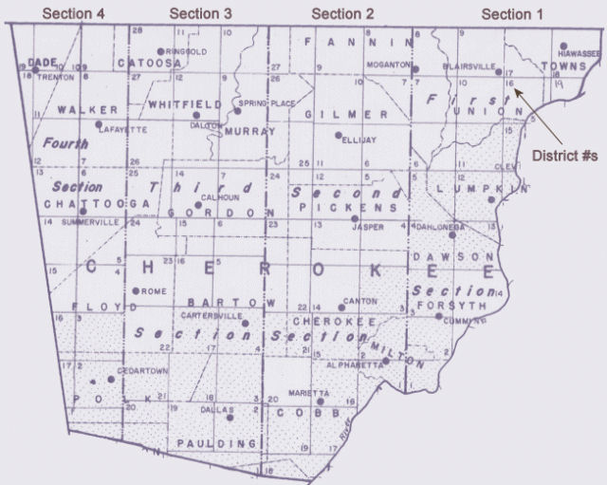

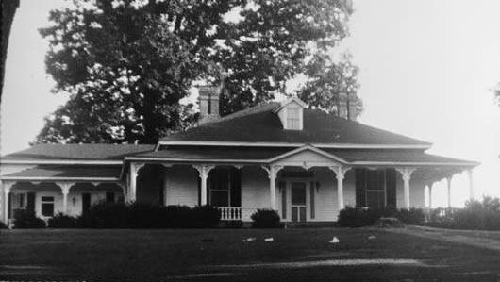
Cobb County's first State Senator, John Gann, built the Gann House just west of Nickajack Creek on present-day Concord Road in 1841. It is the oldest remaining building in the Smyrna area.
Home of State Senator John Gann, who represented Cobb County in 1842, just west of the Concord Covered Bridge over Nickajack Creek, and south of the battlefield where the Battle of Ruff's Mill took place on July 4, 1864. The home was spared because a Masonic apron was found in the attic.

Henry Gann, John Gann, and William Gann are listed among the first pioneers of Cobb County following the Land Lottery in 1832.
John Gann, who became a Georgia State Senator, moved to Cobb from Clarke County about 1836. Senator Gann’s ante-bellum home stands today on the south side of Concord Road, a short distance west of the covered bridge over Nickajack Creek.
John Gann was from Clarke County; both John Gann, Sr., and John Gann, 2nd, of Jennings District in Clarke, drew land in Cobb.
The estate of Henry T. Gann, minor, for whom John Gann was guardian, was appraised November 1, 1837, and the document shows “1 negro girl by the name of Rose, $450; 1 negro boy Samuel, $450.”
In the 6th U.S. Census, is a list of veterans of the Revolution living in Cobb who may have been pioneer settlers. One of these, John Summers, is known to have been in Cobb in the pioneer period. John
Henry and F.F. Gann are listed as veterans of E Co, 1st Georgia along with A. Gann and Ed. Gann as Veterans of the War Between the States Living in Cobb County, January 1, 1906.
1840 Census Ganns in Cobb County, GA
William Gann born about 1763 age 77 District 992, Cobb, Georgia
Samuel F Gann District 992 2 males under 5y/o, 1 male 20-29, 1 female 5-9y/o, 1 female 20-29 (family of 5)
James Gann District 892 Cobb, Georgia 2 males under 5y/o, 1 male 20-29, 1 female 20-29 (family of 4)
John Gann District 992 Cobb, Georgia 1 male under 5y/o, 1 male 5-9y/o, 1 male 10-14y/o, 1 male 20-29y/o, 2 females under 5y/o, 1 female 20-29y/o, 1 male slave 10-23y/o, 1 female slave 10-23y/o, 9 total, 5 white children under 20y/o
Nathan Gann District 892 Cobb, Georgia 3 males 15-19y/o, 1 male 50-59, 2 females under 5y/o, 2 females 5-9y/o, 3 females 10-14y/o, 1 female 20-29y/o, 1 female 30-39y/o, 2 male slaves under 10y/o, 1 male slave 10-23y/o, 1 male slave 36-54y/o, 2 female slaves under 10, 1 female slave 10-23y/o, 1 female slave 24-35y/o, 21 total persons, 13 free whites, 8 slaves
Nathan Gann District 892 Cobb, Georgia 1 male 15-19y/o, 1 female 15-19y/o, 2 total
Nathan Gann District 992 Cobb, Georgia 2 males 5-9y/o, 1 male 10-14y/o, 1 male 40-49y/o, 3 females under 5y/o, 1 female 10-14y/o, 1 female 40-49y/o, 1 female slave 55-99y/o
Robert Gann District 892 Cobb, Georgia 2 males under 5y/o, 2 males 5-9y/o, 1 male 20-29y/o, 2 females under 5y/o, 1 female 20-29, 8 total

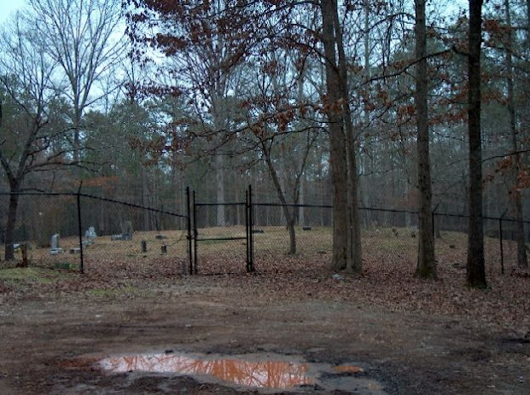
Gann Family Burying Ground
Cooper’s Lake Road, turn off Concord Road 1.8 miles from Smyrna; burying ground is about one-half mile from Concord Road.
Alexander Gann Dec. 25, 1845-Nov. 4, 1912
Mary Sewell Gann Apr. 25, 1850-Dec. 20, 1928
Elizabeth wife of Henry Gann Feb. 7, 1820-Nov. 12, 1899
Henry Gann b. Clarke Co., Ga., 1816 Settled in Cobb Co., 1836 d. Jan. 24, 1914, Smyrna, Ga. Husband of Elizabeth Gann.
P. Y. Gann May 13, 1859-Dec. 9, 1919
The following are the children of Henry and Elizabeth Gann:
Norris Gann 1857-1893
Elizabeth Rosetta Gann wife of W. H. Baldwin 1849-1927
Jane Gann wife of Reuben Buchanan 1851-1890

Gann Family Burying Ground
Cooper’s Lake Road, turn off Concord Road 1.8 miles from Smyrna. This is the original Gann Family Burying Ground and is about ¾ mile from the second burying ground of this family.
John Summers, a Revolutionary Soldier, who was Henry Gann’s maternal grandfather, is buried here. There are probably six graves in all, none marked. On a slight elevation about 200ft. from the burying ground was a battery during the battles between the Confederate and Union Armies in 1864. The breastworks veered off to the side of the burying ground, and are now plainly discernible only a few steps away on one side.

Concord Baptist Church Cemetery
Concord Road, near Floyd’s
Francis Gann Jan 11, 1820-Mar. 24, 1909
Edmond Gann Feb 13, 1825-Apr. 11, 1867
Francis F. Gann Aug. 10, 1834-Nov. 18, 1917
Louise Wade Gann Feb. 4, 1837-Sept. 2, 1914
Mary Elizabeth dau. Of F.F. and L. Gann b. Dec 15, 1855. Aged 8 mos
John Gann 1812-1881
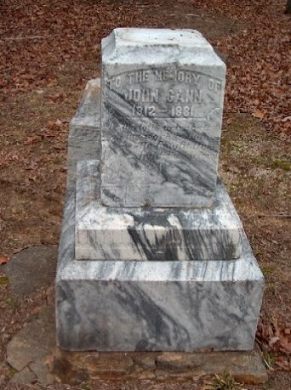

Milford Cemetery
Turn off Marietta-Austell Road 6 ½ mi. from Marietta, Cemetery is about ½ mi. south of main road.
H. T. Gann Mar. 14, 1830-Jan. 16, 1909
S. C. Gann wife of H. T. Gann Jan. 14, 1833-May 23, 1904
J. H. Gann June 18, 1872-Sept. 12, 1915

