John Summers (1762-1848) came to Cobb County from Clarke County with the families of daughter Elizabeth who married William Gann and daughter Mary who married Nathan Gann. They all settled between Mableton and Smyrna along Nickajack Creek. John Summers was quite elderly when he became a citizen of South Cobb, but he must have been active since he at once joined the Concord Baptist Church and took part in church affairs. His time in Cobb County was short and he died in September of 1848 at the age of 86. Burial was in the Old Gann Cemetery on what is now Cooper Lake Rd., Smyrna, Ga. This cemetery was completely destroyed when a subdivision was developed on the site in the early 1960’s. In 1974 descendants placed a marker to his memory in the “New” Gann Cemetery, Smyrna, Ga.
John Summer’s long and adventurous life began on May 26, 1762 in Fairfax County, Va. near the city of Alexandria. The Summers family had been residents along the Potomac River in Maryland and Virginia as early as 1690. John had barely reached 14 and enrolled in the Fairfax Militia when in late July of 1776 the British ascended the Potomac and threatened Alexandria. John and his fellow militiamen were called up to protect the city and county along the river. They were out for two or three weeks but apparently there was no contact with the British.
Later his family moved to Caswell County, N.C. and he remained here until the end of the Revolution. John served as a private in the North Carolina Militia on four different occasions. He fought the British in battles at Stono Ferry, S.C. (June 20, 1779) and at Camden, S.C. (August 16, 1780). The Battle of Camden was a terrible defeat for the American forces under Gen. Gates and it was in this fighting that John was wounded in the left hand, his forefinger nearly shot off. He also fought in local engagements with the Tories.
He married Mary Kimbrough in July 1783. After the end of the war, John and Mary Summers moved into Georgia, settling first in Wilkes Co. About 1803 they moved into Clarke Co. where most of their children married. The Summers were members of Mars Hill Baptist Church and John was evidently a faithful member, although in 1808 he was cited for allowing fiddling and dancing in his home. Mary Kimbrough Summers died sometime between 1820 and 1830, and John began to live with his children. His move into Cobb County was no doubt because of the desire of his sons-in-law to find new and better farm lands.

The Battle of Stono Ferry was an American Revolutionary War battle, fought on June 20, 1779, near Charleston, South Carolina. The rear guard from a British expedition retreating from an aborted attempt on taking Charleston held off an assault by poorly-trained militia forces under American General Benjamin Lincoln.
The opening move in Britain's "southern strategy" to regain control of its rebellious colonies, was the December 1778 capture of Savannah, Georgia. This heightened concerns in Charleston, South Carolina, where General Benjamin Lincoln headed the Continental Army's southern command, and the British garrison at Savannah was about the same size as his own.
By mid-April, Charleston was reinforced by the arrival of South Carolina militia, and Lincoln decided to attempt the capture of Augusta, Georgia, which was defended by a smaller garrison of British troops and Loyalists. He marched from Charleston on April 23. When British General Augustine Prevost learned of this movement, he decided to counterthrust against militia forces at Purrysburg, South Carolina, just upriver from Savannah, marching 2,500 men out on April 29. The militia at Purrysburg, about 1,000 men under the command of General William Moultrie, fell back toward Charleston rather than engaging Prevost, and sent messengers to Lincoln warning him of the British movement. Prevost decided to pursue them almost all the way to Charleston.
On May 10, companies from the two forces skirmished near Ashley Ferry, about seven miles (11.3 km) from Charleston. Two days later Prevost intercepted a message from which he learned that Lincoln was rapidly marching back to Charleston, and decided to retreat. His army was slowed by having taken supplies en route, so he decided to leave a rear guard at Stono Ferry, between Johns Island and the mainland, removing most of his army to Savannah by boat on June 16. Prevost placed Lieutenant Colonel John Maitland in charge of the rear guard, which numbered about 900 men. A bridgehead was established on the north side of an area now known as New Cut Church Flats; this was meant to cover Stono Ferry. Three strong redoubts were built, circled by an abatis and manned by Highlanders and Hessians.
Lincoln, on his arrival in Charleston, decided to mount an attack on this outpost. Even though he commanded five to seven thousand men, he was only able to raise about 1,200 men, primarily from the poorly-trained local militia, for the expedition. General Moultrie led a smaller secondary effort to the east against a small group of British soldiers on Johns Island.
Lincoln deployed his troops after a night march of eight miles (13 km) from the Ashley Ferry, located in the present village of Drayton Hall. Immediately upon their arrival at dawn, they began struggling through thick woods. The Americans advanced in two wings; General Jethro Sumner led his Carolina militia on the right, carrying two guns, while their right flank was covered by a company of light infantry, commanded by the Marquis de Malmady. Continental Army troops, under General Isaac Huger, made up the left wing; they carried four guns into battle. With Huger was a group of light infantry under John Henderson, and it was these troops who, shortly before sunrise, made first contact with the enemy.

Battle
The battle began well for the Patriots. They engaged the British positions with small arms and cannon fire for an hour, at which point they advanced to the abatis. Of the Highlanders, two companies resisted until only 11 men were left standing; a Hessian battalion finally broke. Here Maitland shifted his forces in an attempt to counter the larger threat posed by Huger's wing. The Hessians rallied and returned to the fight, and reserves were brought across the bridge. Lincoln chose this moment to order a withdrawal.
Aftermath
The American loss in the battle was 34 killed, 113 wounded and 155 missing.^{[1]} Among the dead was Hugh Jackson, brother of future President Andrew Jackson, who was felled by heat and exhaustion. Huger was severely wounded. The British casualties were 26 killed, 93 wounded and 1 missing.^{[2]}
Maitland had decided almost a week prior to the battle to withdraw from battle; however, his action was delayed by a lack of water transportation. Finally, on June 23 he began moving towards Beaufort, although with little prompting from Lincoln's attack.
The site of the battle is still visible today, at the end of S. C. 318 near Rantowles.
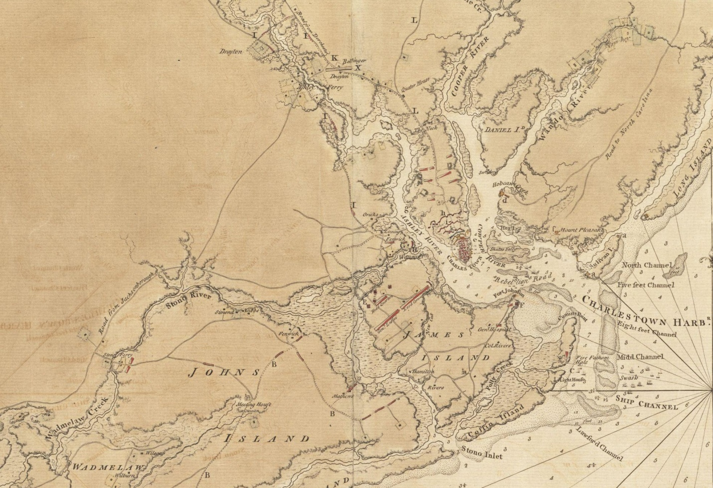

The Battle of Camden was a major victory for the British in the Southern theater of the American Revolutionary War (American War of Independence). On August 16, 1780, British forces under Lieutenant General Charles, Lord Cornwallis routed the American forces of Major General Horatio Gates about 10 km (six miles) north of Camden, South Carolina, strengthening the British hold on the Carolinas following the capture of Charleston.
The rout was an embarrassing defeat for Gates, whose army had possessed massive numerical superiority over the British force, and he never held a field command again. His political connections, however, helped him avoid inquiries and courts martial into the debacle.
Following the British defeat at Saratoga in 1777 and French entry into the American Revolutionary War in early 1778, the British decided to renew a "southern strategy" to win back their rebellious North American colonies. This campaign began in December 1778 with the capture of Savannah, Georgia, and gained further ground in January 1780, when General Sir Henry Clinton led an army and captured Charleston, South Carolina. Clinton returned to New York in the summer of 1780, leaving Lord Cornwallis the task of fortifying the South and raising the anticipated large numbers of Loyalists. The Continental Army in the south, most of which had surrendered at Charleston, was completely driven from South Carolina in the May 1780 Battle of Waxhaws.
The only Patriot resistance remaining in South Carolina consisted of militia partisan companies under commanders like Thomas Sumter, William Davie, and Francis Marion. The Continental Army began to reform at Charlotte, North Carolina under Horatio Gates, the "hero of Saratoga". Gates arrived in late July, and met with the local militia and Continental Army commanders. Against the advice of council, Gates, even before he knew the full capabilities of the troops under his command, ordered a march into South Carolina through an area he had been advised had strong Loyalist tendencies. A significant number of his troops were relatively untested militia companies, and even some of the Continentals under his command had little battlefield experience.
Because of its crossroads location, Camden was considered a key to controlling the back country of the Carolinas. On July 27, Gates advanced into South Carolina, heading towards Camden, then garrisoned by about 1,000 men under Lord Rawdon.^{[3]} Gates established a camp at Rugeley's Mill, north of Camden, where he was joined by militia companies from North Carolina and Virginia. The weather was extremely hot, and a significant number of troops were put out of action by the heat and diseases like dysentery. Although Gates had over 4,000 men in camp, only about 2000 of them were effective for combat, in part because Gates further reduced their numbers by sending several hundred men in support of operations by Sumter and Marion.
General Cornwallis, alerted to Gates' movement on August 9, marched from Charleston with reinforcements, arriving at Camden on August 13, bringing the effective British troop strength over 2,000 men.
Gates formed up first on the field. He had around 3,700 troops, of which around only 1,500 of them were regular troops. On his right flank he placed Mordecai Gist, Johann de Kalb's 2nd Maryland and a Delaware Regiment. On his left flank, he placed 2,500 untried North Carolina militia under Colonel Richard Caswell. Gates stayed with the reserve force, the 1st Maryland Brigade under William Smallwood. Gates placed seven guns along the line. Behind the militia, he placed companies of cavalry and light infantry. With this formation, a typical British practice of the time, Gates was placing the untested militia, his weakest forces, against the most experienced British regiments, while his best troops would face the weaker elements of the British forces.
Cornwallis had around 2,100 men, of which around 600 were Loyalist militia and Volunteers of Ireland. The other 1,500 were regular troops. Cornwallis also had the infamous and highly experienced Tarleton's Legion, around 250 cavalry and 200 infantry who were formidable in a pursuit situation. Cornwallis formed his army in two brigades. Lord Rawdon was in command of the left wing, facing the Continental Infantry with the Irish Volunteers, Banastre Tarleton's infantry and the Loyalist troops. On the right was Lt. Col James Webster, facing the inexperienced militia with the 23rd Royal Welch Fusiliers and the 33rd Regiment of Foot. In reserve, Cornwallis had two battalions of the 71st Regiment of Foot and Tarleton's cavalry force. He also placed four guns in the British centre.^{[3]}
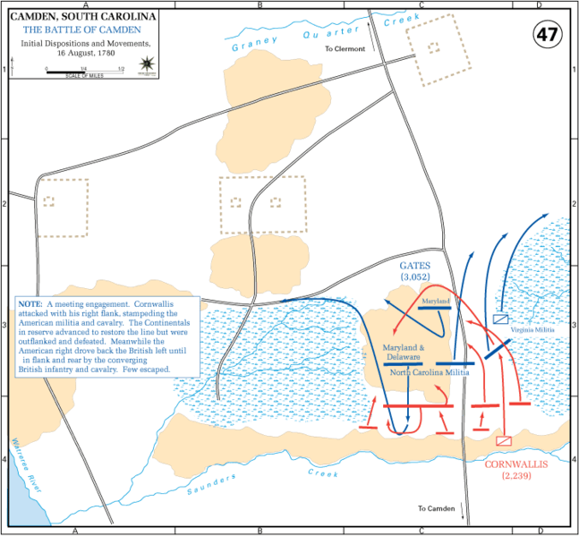
Both armies advanced at each other just after dawn. The British troops opened the battle, when the right flank fired a volley into the militia regiments, causing a significant number of casualties. They followed the volley up with a bayonet charge. The militia, lacking bayonets, panicked and fled before the British regiments even reached them. Only one company of militia managed to fire a volley before fleeing. The panic quickly spread to the North Carolina militia, and they also broke ranks and fled. Seeing his left flank collapse, Gates fled with the first of the militia to run from the field. Within a matter of minutes, the whole American left wing had evaporated. The Virginia militia ran away so quickly that they suffered only three casualties.^{[4]}
While the militia was routing, and before Gates' flight, he ordered his right flank under de Kalb to attack the opposing British militia forces. Rawdon's troops advanced forward in two charges, but a heavy fire repulsed his regiments. The Continental troops then launched a counter attack which came close to breaking Rawdon's line, which began to falter. Cornwallis rode to his left flank and steadied Rawdon's men. Instead of pursuing the fleeing militia, Webster wheeled around and launched a bayonet charge into the left flank of the Continental regiments in the center.
The North Carolina militia that had been stationed next to the Delaware regiment held its ground, the only militia unit to do so. The Continental regiments fought a stiff fight for some time, but only 800 Continentals were by this time facing over 2,000 British troops. Cornwallis, rather than fight a sustained fight with a heavy loss, ordered Tarleton's cavalry to charge the rear of the Continental line. The cavalry charge broke up the formation of the Continental troops, who finally broke and fled.
De Kalb, attempting to rally his men was shot eleven times by musket fire. After just one hour of combat, the American troops had been utterly defeated, suffering over 2,000 casualties. Tarleton's cavalry pursued and harried the retreating Continental troops for some 20 miles (32 km) before drawing rein. By that evening, Gates, mounted on a swift horse, had taken refuge 60 miles (97 km) away in Charlotte, North Carolina.
The British casualties were 68 killed, 245 wounded and 11 missing.^{[1]} Hugh Rankin says, "Of the known dead, 162 were Continentals, 12 were South Carolina militiamen, 3 were Virginia militiamen and 63 were North Carolina militiamen".^{[5]} David Ramsay says, "290 American wounded prisoners were carried into Camden after this action. Of this number, 206 were Continentals, 82 were North Carolina militia and 2 were Virginia militia. The resistance made by each corps may in some degree be estimated from the number of wounded. The Americans lost the whole of their artillery - 8 field pieces, upwards of 200 wagons and the greatest part of their baggage."^{[6]} A letter from Cornwallis to Lord George Germain, dated 21 August 1780, says that his army took "about one thousand Prisoners, many of whom wounded" on August 18.^{[7]} The website Documentary History of the Battle of Camden, 16 August 1780 details on its Officer Casualties at Camden page the fates of 48 Continental officers at Camden: 5 were killed, 4 died of wounds, 4 were wounded without being captured, 11 were wounded and captured and 24 were captured without being wounded. These ratios would suggest that a significant number of the Americans wounded in the battle escaped capture.
The Camden Battlefield, located about 5 miles (8.0 km) north of Camden, is owned by the Daughters of the American Revolution, and is undergoing preservation in a private-public partnership. The site was declared a National Historic Landmark in 1961, and placed on the National Register of Historic Places in 1966.
Aspects of the battle were included in the 2000 movie The Patriot, in which Ben and Gabriel Martin are seen watching a similar battle. Ben comments at the stupidity of Gates fighting "muzzle to muzzle with Redcoats". The film is not historically accurate, depicting too many Continental troops relative to the number of militia, and that the Continentals and militia retreated at the same time.

