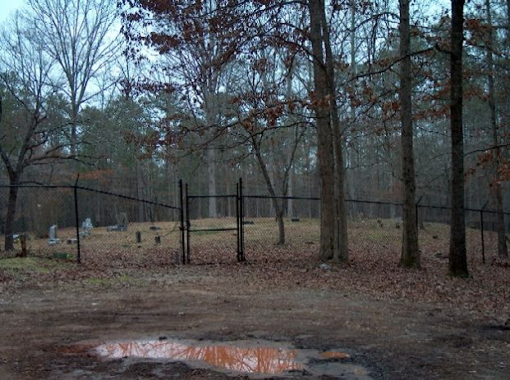

COBB COUNTY, GA - CEMETERY Concord Baptist Church

Copyright. All rights reserved.
http://www.usgwarchives.net/copyright.htm

This file was contributed for use in the USGenWeb
Archives by: "Leah" <uranut@bellsouth.net>

Table of Contents page:
http://www.usgwarchives.net/ga/cobb.htm
Georgia Table of Contents: http://www.usgwarchives.net/ga/gafiles.htm

CONCORD BAPTIST CHURCH CEMETERY
Fowler Road
Mableton, Cobb County, Georgia
Floyd Station Community

Directions: From SW Concord Road, turn north on South
Hurt Road. Fowler Road will be the first road on the
right. Cemetery is all the way down the road to the
dead end. The Church is at the corner of Concord and
Floyd Roads. Established in 1832, Concord Baptist is
one of Cobb County's oldest churches.

Disgust was my impression from this visit to the
cemetery. It has been completely vandalized. Most
of the markers are gone. The remaining markers that
were either too big or too heavy to carry are knocked
off their bases. I called the Cobb Historic
Preservation office and Mike Fortenberry told me that
the County first installed an expensive iron fence. He
said someone had stolen it by hooking a chain to it
and pulling it up. Since then the County has installed
a chain link fence which now has a big hole cut in it.
Mr. Fortenberry said the local youths who party in the
cemetery are the culprits and that the County Parks and
Recreation Department have the missing markers in
storage.

This survey is supplemented by the Cobb County
Cemeteries book. The markers that still remain in the
cemetery are denoted with an asterisk (*).

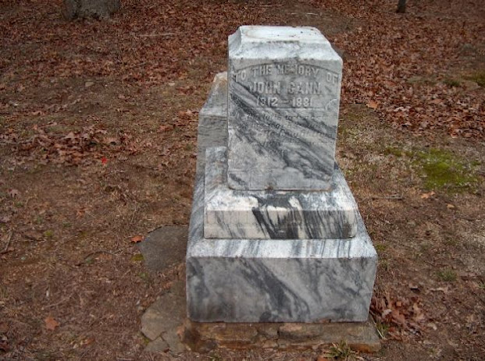

GANN, John (*) 1812 Aug 1881 Son of Nathan Gann
GANN, Mary Ann Allen 04 Feb 1814 08 May 1856 Second w/o John Gann
GANN, Nancy O. Reed 23 Feb 1824 15 May 1908 Third w/o John Gann; d/o Daniel
Reed (1835 birth year on stone in error)
GANN, Alice June 1861 28 Sep 1906 d/o John & Nancy Gann

Double Stone:
GANN, Francis F. (*) 10 Aug 1834 18 Nov 1917 s/o John Gann - Father
GANN, Louise Wade (*) 04 Feb 1837 02 Sep 1914 d/o Harris Wade - Mother

GANN, Mary Elizabeth 15 Dec 1855 d/o F.F. & L. Gann - Aged 8 months

GANN, Edmond 13 Feb 1825 11 Apr 1867
GANN, Francis 11 Jan 1820 24 Mar 1909 Mother - w/o Edmond Gann

BURDINE, Amanda M. 13 Nov 1830 13 Jul 1879 Unmarried; d/o Samuel Burdine

HILL, T.J.D. 01 May 1861 01 Sep 1861 DOB could be 07 May 1861

MOSS, James C. 12 Jun 1837 13 Apr 1860 Masonic (Springville #153 Powder
Springs) s/o Alfred Moss
MOSS, Cenith L. 17 Nov 1869 20 Apr 1884 d/o James C. & Harriett N. Burdine
Moss
MOSS, Ida Cornelia 08 Mar 1868 23 Dec 1868
ALLEN Base of marker only
MOSS, Homer A. (*) 18 Mar 1872 04 Apr 1907 s/o James C. Moss
GLORE, Martha A. (*) 21 Feb 1862 24 Aug 1900 Mother; d/o James C. Moss; w/o
Thomas A. Glore
MOSS, Clarence E. (*) 06 Apr 1879 04 May 1915 Masonic (Latham #12 Austell)
s/o James C. Moss

SCROGGINS, George 02 May 1836 24 May 1876 Father; s/o of James F. Scroggins
SCROGGINS, Luther E. 02 Jun 1870 20 Mar 1877 s/o George C. Scroggins & Nancy
Jane Pace

FLOYD, A. T. Base only & footstone A.T.F.
FLOYD, Sarah E. (*) 29 Oct 1837 03 Nov 1910 Mother
THOMAS, Henry A. 04 Jul 1880 09 Feb 1885 s/o M/M J.A. Thomas
THOMAS, Robert A. 18 Mar 1891 04 Sep 1893 s/o M/M J.A. Thomas

PENDLEY, L.J. Mrs. 10 Aug 1850 14 Nov 1873 Daughter, Wife, Mother and Sister
PENDLEY
PENDLEY Grandmother Aged 80 years
BROUGHTON, Mattie 05 Jun 1858 19 Dec 1907 w/o Sam L. Broughton (black)

NOTES:

Just a few hundred feet from Concord Church is Floyd
Station that was built in 1905. Floyd Station was a
watering stop during the days of steam locomotives,
then a general store and now a bicycle shop for folks
who want to ride on the Silver Comet Trail. The
Seaboard Coastline tracks ran alongside the station,
shuttling people between Atlanta and Birmingham. The
tracks have been replaced with a cement ribbon for
recreation.

As late as the 1970's, across from the Church stood a
one-room schoolhouse where a landscaping nursery is
now. The children who graduated from "Floyd College"
are long gone.

There are several historical locations within a few
miles of Concord Church: Concord Covered Bridge, the
Gann House, the Mable House and others. Unfortunately,
these same youths who destroyed the cemetery will
undoubtedly ruin the entire historical area.

