Another Nathan Gann
The title of this article comes from a play on words taken from “The Ignatious Nathan Gann Family: Three Generations of Pioneers” by William R. Gann and Gary R. Toms. On page 192 the authors mention ‘Three men named Nathan Gann’ and discuss the challenges of distinguishing between different individuals with the same name. Well, I’m here to add to the confusion just a little bit more.
This is the story of a man named Nathan Gann who was born about 1802-1804 in Tennessee. He is close to the age of Nathan Gann, the son of Adam Gann and Rosina Broyles, which helps to add to the confusion. That Nathan Gann was born in 1805 in Washington County, Tennessee, married Serena Frazier in 1820, and moved to Missouri dying there in 1869 in Livingston County. The earliest by name documentation of Nathan and Sarah Gann is from the 1850 Census of Fayette County, Georgia. He was perhaps listed on the Census of 1830 and 1840, but this could have been a different Nathan Gann (Ignatious Nathan Gann son of Adam Carter Gann from Washington County, Tennessee). I will argue the hypothesis that it is the same Nathan Gann was listed on the 1830, 1840, and 1850 Censuses.
This census was conducted on the 16th day of October, 1850 in the Twentyninth District of Fayette County, Georgia.
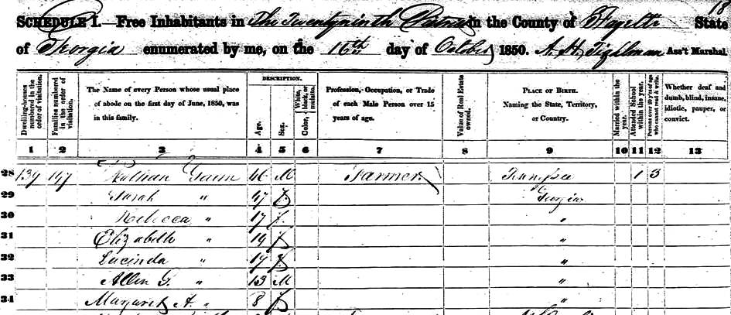
Edited picture of the 1850 Fayette County, Georgia Census record.
What we first learn about Nathan Gann from this 1850 Fayette County, Georgia Census record is that he is already middle aged at 46 years of age. He was born in Tennessee about 1804 according to this record. His wife Sarah is stated as 47 years of age and was born in Georgia. This helps to establish a couple of observations. First, this is not Sarah Delaney who married Ignatious Nathan Gann on 24 December, 1817 in Kingston, Roane County, Tennessee. This Sarah was born about 1804 and would have been only 13 years old at that time. Second, Nathan most likely moved down from Tennessee to Georgia as a young single man. He must have married Sarah in Georgia, as she was born in Georgia and all of their children are listed as being born in Georgia. I have not found any marriage records yet.
Where did they live?
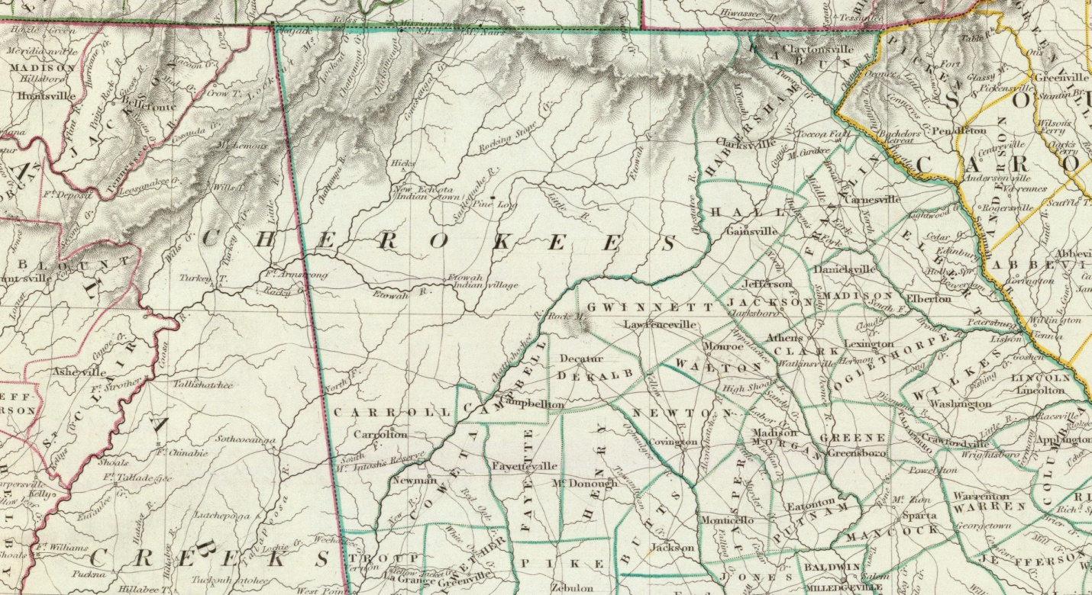
1833 Georgia Map
Fayette County, Georgia was created on May 15, 1821 by an act of the General Assembly (Ga. Laws 1821 Extra. Session, p. 3). Dooly, Houston, Monroe, Fayette, and Henry County were created in that order by the Georgia Land Lottery Act of 1821, which was enacted at a special session of the General Assembly four months after the Creek Indians ceded lands between the Ocmulgee and Flint rivers on Jan. 8, 1821 in the Treaty of the Indian Spring.
Fayette County was organized by an act of the legislature approved Dec. 24, 1821 (Ga. Laws 1821, p. 44). That same act added the 4th, 5th, 13th, 14th, and 17th districts of Henry County to Fayette County. Later, portions of Fayette County were used to create the following counties: DeKalb (1822), Campbell (1828), Spalding (1851), and Clayton (1858).
Georgia's 51st county was named the Marquis de Lafayette (1757-1834), a French adventurer who at age 20 accepted a commission as major general in the Continental Army during the American Revolution. Lafayette became a trusted field officer and friend of Gen. George Washington, and was widely considered a hero in America.
Some of Fayette County was given away in the 1821 Land Lottery. The drawing was held November 7, 1821 - December 12, 1821. In Fayette County, 4 districts (6, 7, 9, 14) were part of the lottery.

History of Fayette County by George White
http://www.usgennet.org/usa/ga/county/fulton/fayette/history.htm
This county is a portion of the territory acquired by the United States for the use of the State of Georgia, from the Creek Indians, by a treaty made at the Indian Springs. Organized in 1821, and named after the Marquis De La Fayette. Length, 27 m; breadth, 18 m.; area square miles, 486.
The Flint River passes along the eastern part of the county.
Fayetteville is the county town, 107 miles from Milledgeville. Jonesborough is a thriving place, situated on the Macon and Western Railroad.
Rough and Ready, and Fairburne, are small places.
The face of the country is level. The lands are of the gray quality, adapted to cotton, corn, &c.
The climate is healthy. We insert a few cases of longevity. Mr. Waldroup died at 104; Mr. Graves, over 80; Wm. Gay, over 80; Mr. Hanes, 87; Mr. Grey, 80; John Fuller, 96; Mr. Moses 80; Mrs. Atkinson, 80; E. Knowles, 80; Wm. Powell, 90; John Cooke, 95; Wm. Abercrombie, 86; Mr. S. Speights, 85.
General David Dickson died in the county in 1830, aged 79 years. He joined the standard of American Independence in February, 1775, at the Snow Camps, on Reedy River, at the taking of Colonel Cunningham and his Tories. In 1776, he commanded a volunteer company, under General Williamson, in the Cherokee Nation, against the Cherokees and Tories. In 1777, he brought a company of minute-men to Georgia and was stationed on the frontiers. In 1778, he and his company went with the American Army to take St. Augustine, and served in the artillery. The taking of St. Augustine miscarried; the minute-men were discharged, and he returned to South Carolina, joined the standard of Independence, and continued in the service of his country to the end of the war.
Samuel Parsons died in 1832, aged 70 years. He was a native of the State of Virginia. At the age of fifteen he entered the army of the revolution, was engaged in the battle of Guilford Courthouse, at the siege of Little York, and witnessed the surrender of Lord Cornwallis.
Extract from the Census of 1850. -- Dwellings, 1,196; families 1,206; white males 3,450; white females, 3,290; free coloured males, 3; 1 free coloured female. Total free population, 6,744; slaves, 1,965. Deaths, 99. Farms, 818; manufacturing establishments, 6. Value of real estate, $2,185,835; value of personal estate, $1,162,169.
The first Superior Court for this county was held on the 22nd of April 1824.
His Honor Eli Shorter, Judge.
Grand Jurors.
James Strawn Wm. Gilleland
Wm. Morgan Wm. Powell
Matthew Burge, Larkie Laudneur
Wm. Watts, John Chambers
Joseph H. Shaw, Stephen Smith
John Levi, Wm. Harries
Charles Lisles, James Garratt
James Head, R. Barrow
A. Tilghnauw
[Transcribed by Brenda Pierce]

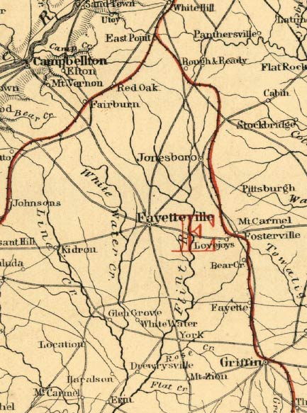
1830 Fayette County, Georgia Census

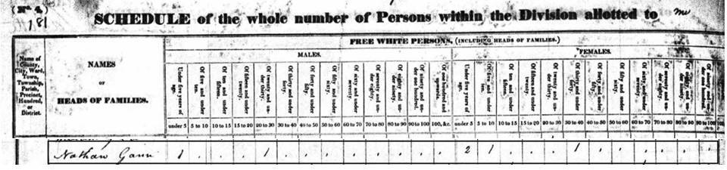
Edited picture of Census

Here is how I hypothesize the members of the Nathan Gann household in 1830:

Nathan Gann (Male head of household)
One male child under 5: William b. 1827
One male 20 to 30: Nathan
Two females under 5: Rhoda C. b. abt. 1825-26 and Mary Ann b. abt. 1826
One female 5 to 10: Louisa b. abt. 1822-1823
One female 30 to 40: Sarah
Six total members of the Nathan Gann household

1840 Fayette County, Georgia Census

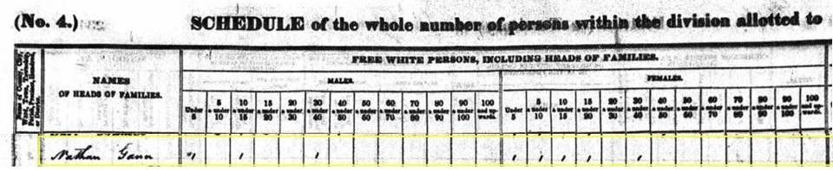
1840 Census edited

Here is how I hypothesize the members of the Nathan Gann household in 1840:

Nathan Gann (Male Head of Household)
One male under 5: Green Allen Gann b. 1837
One male 10-15: William Gann b. 1827
One male 30-40: Nathan Gann
One female under 5: Martha Elizabeth Gann b. 1836
One female 5-10: Mary Ann Gann b. 1825-1826
One Female 10-15: Rhoda C. Gann b. 1826
One Female 15-20: Louisa Gann b. 1823
One Female 30-40: Sarah Gann
Eight total members of the Nathan Gann Household

Notes:
The family of Usibious Slaton (father of Gehazi and Thomas N. Slaton) is listed on the same page as Nathan Gann.

1850 Fayette County, Georgia Census
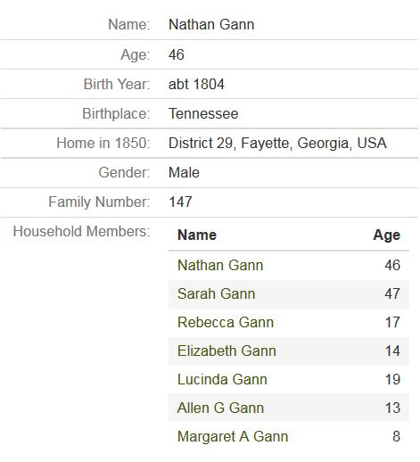 | Looking at the ages of the children listed, it would seem like there are possibly older children not listed in the census that have already married and started their own families. Lucinda at 19 is the oldest child listed, and Sarah would have been about twenty eight years old when she was born.

There are four other children of Nathan and Sarah Gann that are not listed in the 1850 Census who were old enough to marry and leave the household. Marriage records from this era reveal more information about family members than the Census of 1840 which does not state all of the family member’s names.
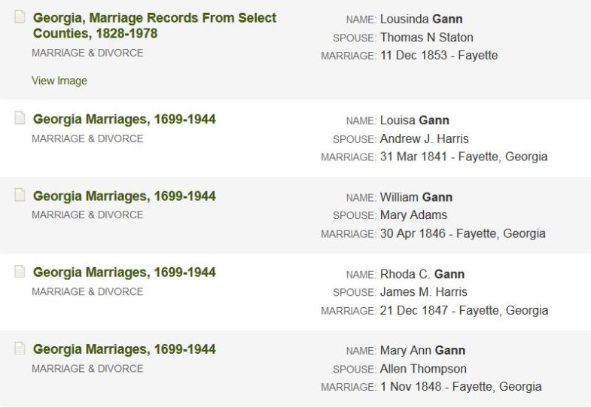

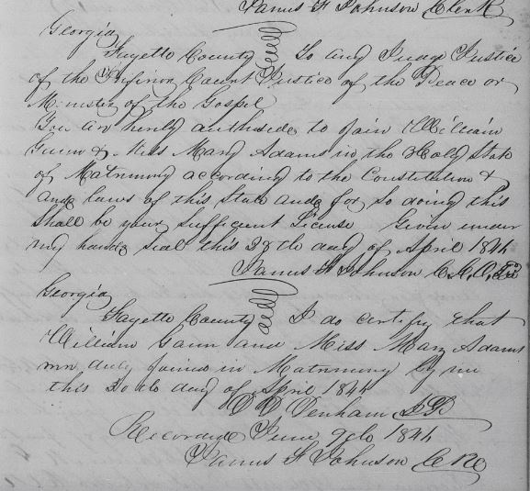
William Gann and Mary Adams Marriage Record
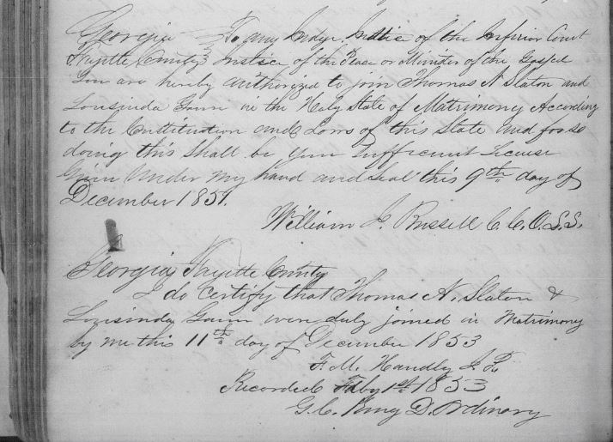
Lousinda Gann and Thomas Slaton Marriage Record
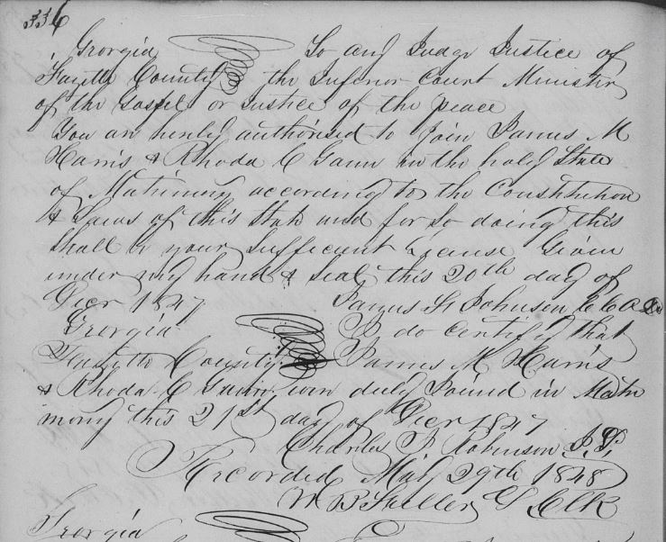
Rhoda Gann and James Harris Marriage Record
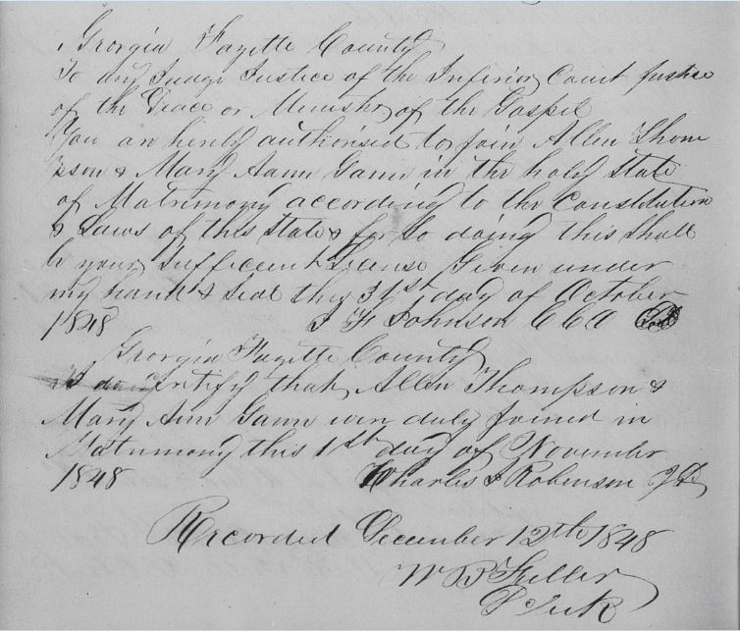
Mary Ann Gann and Allen Thompson Marriage Record

There is one more unaccounted for person that I am referring to as Unknown Male Gann. I think of him much like an astronomer that knows the presence of an unseen planet due to its gravitational effect on the surrounding. You can’t prove it exists because you can’t see it, but you can see its effect on those around him. I cannot account for him by record, but he left behind a family. If he was a son of Nathan and Sarah, he would likely have been born very early in their marriage about 1821 or 1822 in Fayette County. (Unlikely due to not being accounted for in the 1830 and 1840 Census) However, he could also been a relative who came down from Tennessee to Georgia with Nathan. One should consider a genealogy axiom that people usually move as a group rather than individually. Review of the population in Fayette County shows Nathan being the only person of generation in this area that was born in Tennessee on the 1850 Census. This elusive unnamed Gann married Nancy Lipham, who is listed as being 30 years old in 1850. He must have died in late 1849 or 1850 leaving behind a wife and two infants. There is no marriage record to be found, but she did keep using the Gann surname. This makes you consider the older age of Nancy, and ask questions like was she previously married, or was she an old maid? What was the dynamic present that had her having children later in life? Nancy Lipham Gann is listed on the 1850 Census as living with her brother Aaron Sandford Lipham and his wife Pernina; and Nancy’s children Sarah J. Lipham and William R. Gann. They were actually counted twice in the 1850 Census, the first time on 15 October, and the second time on 11 November. Living next door to the Lipham’s is the Harris family. Louisa Harris was the daughter of Nathan Gann. The other next door household is Usevius Slaton, father of Gehazi and Thomas Slaton who married Mary Ann Gann and Rebecca respectively. So we see on the Census record how the neighbors have intermarried. Another genealogy axiom proven- proximity counts! Or as the real estate agents exclaim the three most important factors are 1. Location, 2. Location, and 3. Location.
The importance of the missing Unknown Male Gann will return later in my own lineage.
1850 Census Note: Very few people in this area of Fayette County were born in Tennessee. There were as many born in Connecticut or Vermont as there were from Tennessee, and 3-4 times as many were from Ireland. I reviewed nearly the first half of the county census for only the state of birth to see if someone else living there might have come from Tennessee with Nathan.

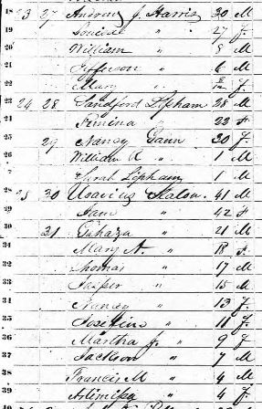 | 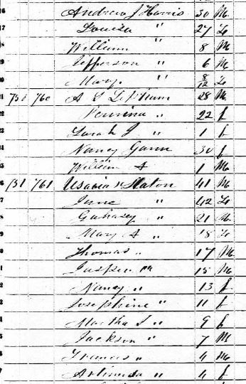
The October Census is on the left, and the November on the right above.

The Move to Randolph County, Alabama
The move to Randolph County began in 1859. On 1 January 1859 William Gann signed a deed for land in Randolph County.
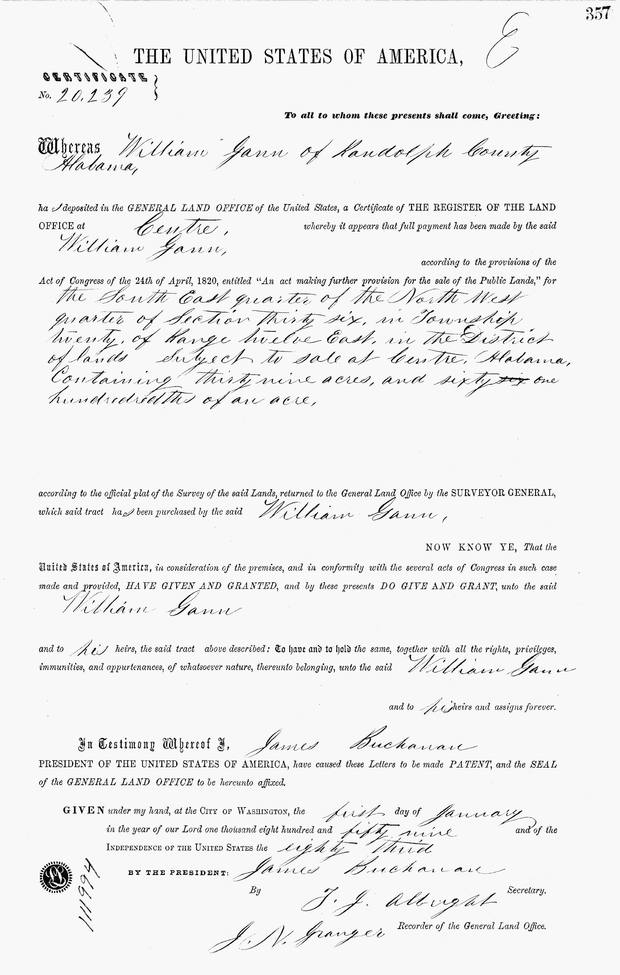
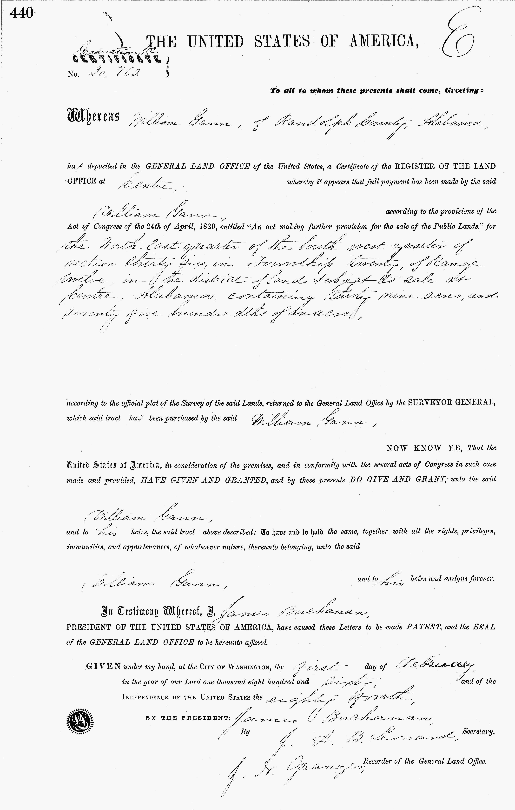
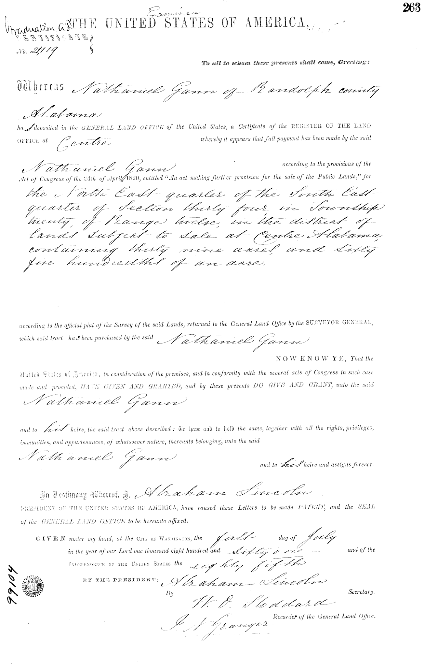
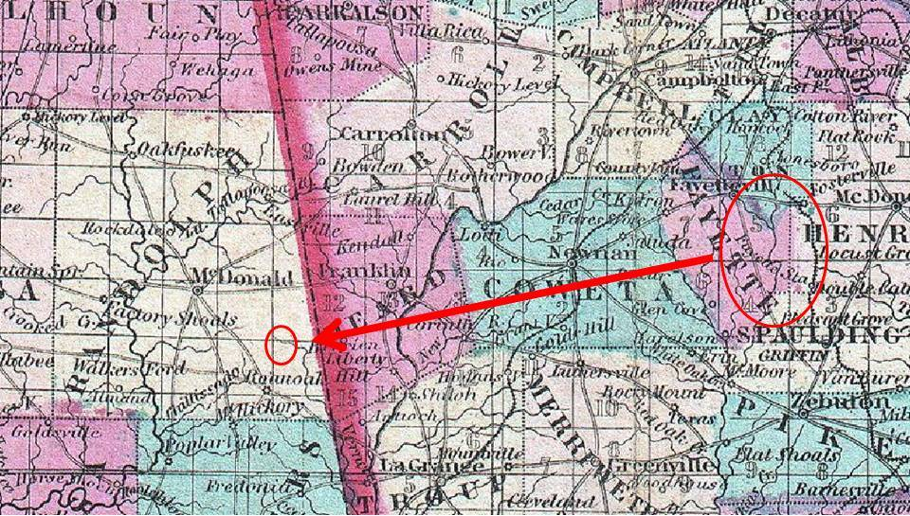
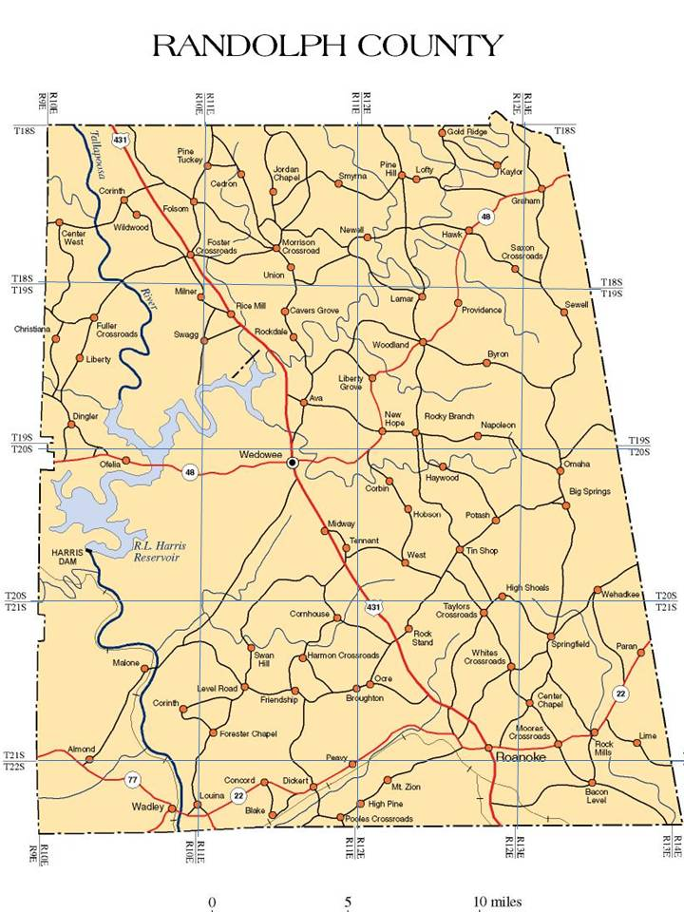 | 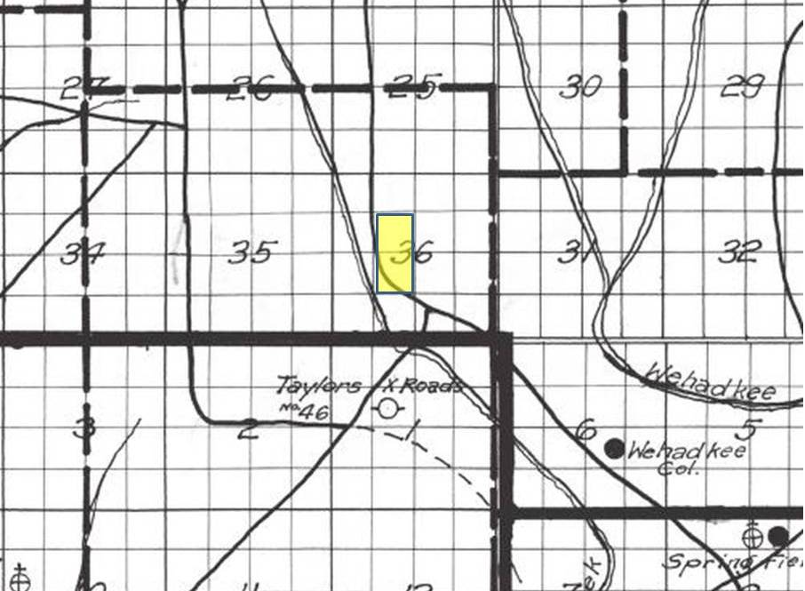

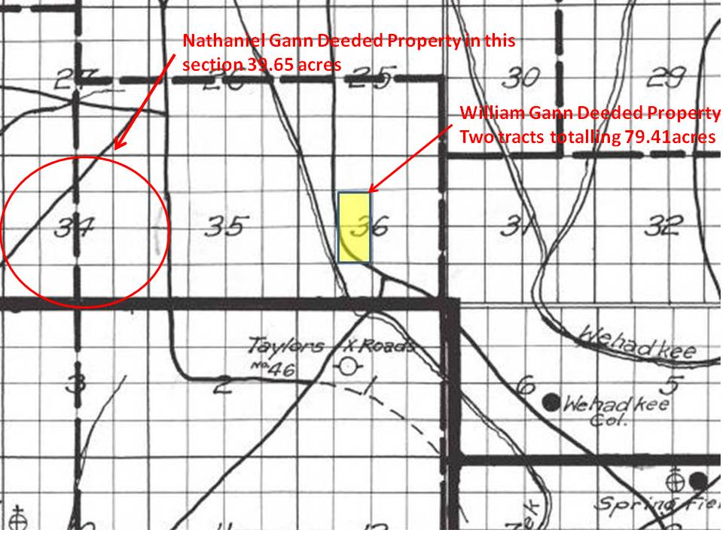

Their property was near Taylor’s Crossroads, which is still present today.

1860 Randolph County, Alabama Census

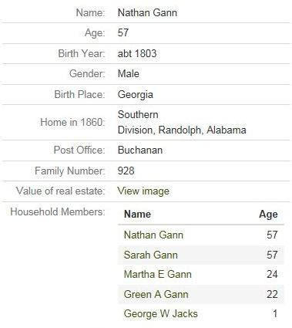
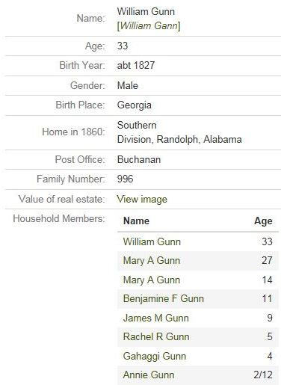
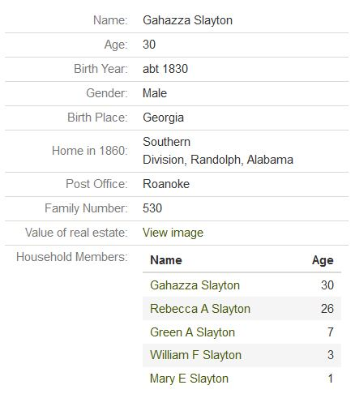

Family Tree of Nathan and Sarah Gann

- NATHAN GANN was born about 1803 in Tennessee and moved to Georgia most likely around 1820-1822. He meets and marries Sarah (unknown maiden name) about 1822 in Georgia. Nathan Gann is listed on the Fayette County Census in 1830, 1840, and 1850. They lived in Fayette County, Georgia until 1860 when they move to west to Randolph County, Alabama. His name was listed as Nathaniel on the land deed in Alabama.
Children of NATHAN and SARAH GANN are:
2. i. LOUISA GANN, born 2 May 1823, Fayette County, Georgia; married Andrew J. Harris on 31 March 1841. She died 24 July 1900 in Bastrop County, Texas.
3. ii. RHODA C. GANN, born about 1825-1826, Fayette County, Georgia; married James M. Harris on 21 December 1847.
4. iii. MARY ANN GANN, born about 1825-1826, Fayette County, Georgia; married Allen Thompson on 1 November 1848.
5. iv. WILLIAM GANN, born 1827, Fayette County, Georgia; married Mary A. Adams on 30 April 1846.
6. v. LUCINDA GANN, born 20 February 1831, Fayette County, Georgia; married Thomas Nixon Slaton on 11 December 1853. Died 8 June 1897 Fairburn, Fulton County, Georgia.
7. vi. REBECCA A. GANN, born 1832, Fayette County, Georgia; married Gehazi Slaton in October 1850. She was widowed by the Civil War, and remarried to Humphrey Posey in 1866. She died in 1916 in Sylvania, De Kalb County, Alabama.
8. vii. MARTHA ELIZABETH GANN, born in 1836, Fayette County, Georgia; she married an unknown man with the surname of Jacks. (Most likely one of the sons of William and Anna Jacks of Fayette County). She was likely widowed.
9. viii. GREEN ALLEN GANN, born about 1837, Fayette County, Georgia; he married Martha Stallings in 1860. He died on 22 March 1928 in Ider, De Kalb County, Alabama.
10. ix. MARGARET GANN, born 1842, Fayette County, Georgia.

- LOUISA GANN (Nathan) born 2 May 1823, Fayette County, Georgia; married Andrew J. Harris on 31 March 1841. She died 24 July 1900 in Bastrop County, Texas. Andrew J. Harris was born in Georgia in 1820 and is thought to have died between 1860-1864.

Children of LOUISA GANN and ANDREW J HARRIS are:
i. William Harris b. 1842
ii. Jefferson Harris b. 1844
iii. Mary Harris b. 1850 d. 1860
iv. Alonzo Doney Harris b. 1854 d. 1918

- RHODA C GANN (Nathan) born about 1824 in Fayette County, Georgia; married James M Harris on 21 December 1847.

- MARY ANN GANN (Nathan) born in 1826 in Fayette County, Georgia; married on 1 November 1848 to a widower Allen Thompson b. 1812 who had several children with a previous wife Martha Ann Stubbs. They resided five houses away from her brother William in Fayette County in 1850.

Children of Allen Thompson and Martha Ann Stubbs are:
- Elizabeth Thompson b. 1835
- Nancy Thompson b. 1837
- James Thompson b. 1838
- Martha Thompson b. 1841
- Mary Thompson b. 1843
- William Thompson b. 1845

- WILLIAM GANN (Nathan) born 1827 in Fayette County, Georgia; married Mary A “Polly” Adams on 30 April 1846. Mary A Adams was born in 1828.

Children of WILLIAM GANN and MARY A ADAMS are:
- Mary A Gann b. 1846
11. ii. Benjamin F. Gann b.1850
12. iii. James Martin Gann b. 1851
- Rachel R Gann b. 1855 d. 1937
- Gahaggi Gann b. 1856
- Annie Gann b. 1860
13. vii. Wiley G Gann b. 1864 d. 1942

- LUCINDA GANN (Nathan) born 20 February 1831, Fayette County, Georgia; married Thomas Nixon Slaton on 11 December 1853. Died 8 June 1897 Fairburn, Fulton County, Georgia.

Children of LUCINDA GANN and Thomas Nixon Slaton are:
- Sarah J Slaton b. 1852 d. 1923
- Mary Slaton b. 1956 d. 1920
- Francina Slaton b. 1857 d. 1920
- Leah Slaton b. 1859 d. 1922
- Ella Slaton b. 1861
- Maggie Slaton b. 1865 d. 1955
- Avolee Slaton b. 1869 d. 1922
- Robert E. Lee Slaton b. 1870 d. 1929
- Charley Slaton b. 1875 d. 1955

- REBECCA A GANN (Nathan) born 1832, Fayette County, Georgia; married Gehazi Slaton in October 1850. She was widowed by the Civil War, and remarried to Humphrey Posey in 1866. She died in 1916 in Sylvania, De Kalb County, Alabama.

Children of REBECCA A GANN and Gehazi Slaton are:
- Green A Slaton b. 1852 d. 1922
- William F Slaton b. 1857 d. 1938
- Mary E Slaton b. 1859
Children of REBECCA A GANN and Humphrey Posey are:
i. Emma Posey b. 1859
ii. Martha H Posey b. 1869 d. 1952
iii. Arthur Posey b. 1870 d. 1955
- Mattie Posey b. 1872 d. 1913
- Dollie Posey b. 1874 d. 1913
- Carrie Posey b. 1877

- MARTHA ELIZABETH GANN (Nathan) born in 1836, Fayette County, Georgia; she married an unknown man who might possibly have been William Jacks (Son of William and Anna Jacks of Fayette County). She was likely widowed.
Children of MARTHA ELIZABETH GANN and William Jacks are:
- George W Jacks b. 1858 d. 1932
- Thomas Franklin Jacks b. 1865 d. 1936

- GREEN ALLEN GANN (Nathan) born about 1837, Fayette County, Georgia; he married Martha Stallings in 1860. He died on 22 March 1928 in Ider, De Kalb County, Alabama. He was a member of Company I “The Roanoke Invincibles”, 13th Alabama Regiment, CSA.

Children of GREEN ALLEN GANN and Martha Stallings are:
- Julia A Gann b. 1866 d. 1955
14. ii. William Gann b. 1868 d. 1939
15. iii. Robert G Gann b. 1871 d. 1943
- Sarah M Gann b. 1873 d. 1963
16. v. John Franklin Gann b. 1876 d. 1944
vi. Josie Gann b. 1877 d. 1970
- Mary Jane Gann b. 1879
17. vii. James G Gann b. 1880 d. 1920
ix. Luther W Gann b. 1884 d. 1942
- Thomas Gann b. 1887 d. 1947

- MARGARET GANN (Nathan) born 1842, Fayette County, Georgia.

- BENJAMIN F GANN, (William, Nathan) born 1850 in Fayette County, Georgia married Mary Fannie Ward (b1858) in Barbour County, AL on 15 December 1881. They lived in Clayton, Barbour County, Alabama.

Children of BENJAMIN F GANN and Mary Fannie Ward are:
i. Aaron Lewis Henry Gann b. 28 June 1883 d. 3 April 1952
- William E Gann b. 25 June 1885 - d. 23 January 1923

- JAMES MARTIN GANN (William, Nathan) was born in December of 1851 in Fayette County, Georgia and died 22 August 1926 in Columbus, Georgia. His first wife was Sallie Spratlin. He married his second wife Caroline “Carrie” Windham on 22 March 1900.

Children of James Martin Gann and Sallie Spratlin are:

- William Gann b. January 1876
ii. Mary “Mollie” Gann b. January 1878
iii. Roxie Gann b. February 1880
iv. Vandy Lee Gann b abt 1882 d. 25 February 1899
v. Emma Gann b. March 1884
vi. Sarah J Gann b. February 1888
vii. Larkin J Gann b. April 1889
viii. Julia Josephine Gann b.1889 d. 25 February 1899
viii. Alice Gann b. April 1894
ix. James G Gann b. March 1896

- WILEY G GANN (William, Nathan) was born 7 October 1864 in Randolph County, Alabama and died 11 April 1942 in East Tallassee, Alabama. He married Nettie L Henderson (1871-1933) on 21 February 1899 in Tallapoosa County, Alabama.

Children of WILEY G GANN and Nettie L Henderson are:
- Genie Gann b. 1887 d. 1966
ii. Henry Lee Gann b. 1887 d. 1970
- Benjamin Gann b. 1891
- Wiley O Gann b. 1893 d. 1935
- Ethel Gann b. 1894
- Pollie I Gann b. 1896 d. 1945
- Willie L Gann b. 1904 d. 1967
- Bessie M Gann b. 1906 d. 1985
- Joe D Gann b 1911

- WILLIAM GANN (Green, Nathan) was born in Randolph County, Alabama in January 1867 and died 31 March 1939 in Dutton, Alabama. He married Nancy Green (b1867) in 1891.

Children of WILLIAM GANN and Nancy Green are:
- Ida Gann b. 1892
- William Henry Gann b. 1893 d. 1967
- Henry Gann b. 1894
- George Boothe Gann b. 1899 d. 1970
- John Dewey Gann b. 1904 d. 1954

- ROBERT G GANN (Green, Nathan) was born in Randolph County, Alabama on 7 June 1871 and died 10 March 1943 in Chattanooga, Tennessee. His first wife was Sarah Jane Braden (d. Aug 1898) He married Laura Davis (1862-1942) in 1900.

Children of ROBERT G GANN and Sarah Jane Braden are:
- James Idrus Gann b. March 1898

- JOHN FRANKLIN GANN (Green, Nathan) was born in January 1876 in Randolph County, Alabama and died 5 October 1944 in DeKalb County, Alabama. He married Martha Jane Barnes (1879-1971) on 4 February 1895 in DeKalb County, AL.

Children of JOHN FRANKLIN GANN and Martha Jane Barnes are:

- Eula L A Gann b. 1895 d. 1920
ii. Bertha L Gann b. 1898 d. 1986
- Alma Gann b. 1901 d. 1931
- Corneilia Gann b 1903 d. 1920
- Estella Gann b. 1906 d. 1930
- Idella Themis Gann b. 1906 d. 1991
- Opal Gann b. 1908 d. 1939
- Daniel W Gann b. 1910 d. 1974
- Floyld Eldridge Gann b. 1911 d. 1974
- Lloyd Gann b. 1911 d. 1967
- Clayton Gann b. 1913 d. 1966
- Roland Gann b. 1915 d. 2005
- Nellon Franklin Gann b. 1917 d. 1987
- RM Gann b. 1924

- JAMES G GANN (Green, Nathan) was born December 1880 in Randolph County, Alabama and died 19 February 1920 in Mount Pleasant, Titus County, Texas. He married Lillie Ray Scott (1886-1952) on 4 December 1904.
Children of JAMES G GANN and Lillie Ray Scott are:

- Thelma Mattie Gann b. 1905 d. 1993
ii. James Reece Gann b. 1907 d. 1996
iii. Hubert Ulman Gann b. 1910 d. 1984
iv. Lilly Irene Gann b. 1914 d. 1990
v. Woodrow Wilson Gann b 1917 d. 1979
vi. Infant Gann b. 1920 d.1920

------------------------------------------------------------------------------------------------------------------------------------------
# UNKNOWN MALE GANN married Nancy Lipham.

Children of UNKNOWN MALE GANN and Nancy Lipham are:
1. i. Sarah J Gann b. 1848
2. ii. William “Willie” A Gann b. 1848 d. 1916

Nancy Lipham was born was born about 1820 in Salem, Clarke County, Georgia to Henry Sandford Lipham (1784-1850) and Nancy Bearden (1791-1850). She has three younger siblings; Jackson Lipham (1822-1875), Aaron Sandford Lipham (1824-1890), and Dicey A Lipham (b.1828). I have found no marriage record between Nancy Lipham and any male Gann. She is first found on the 1850 Census record living in the household of her brother Aaron Sandford Lipham and his wife Pernina. Listed also is Sarah J Lipham (who is actually Sarah J Gann) and William A or R Gann.

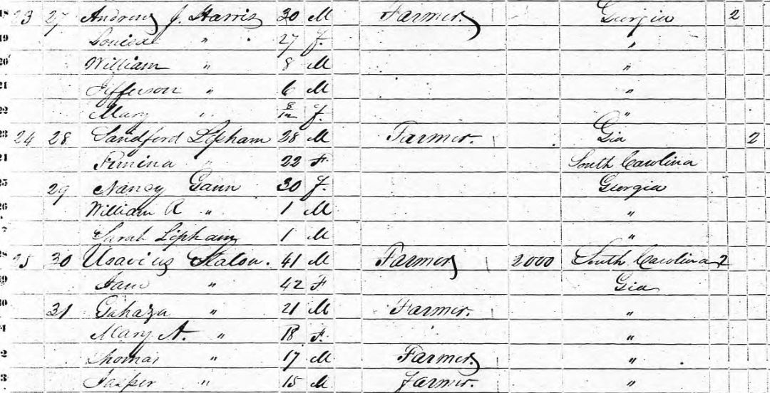
October 1850 Census

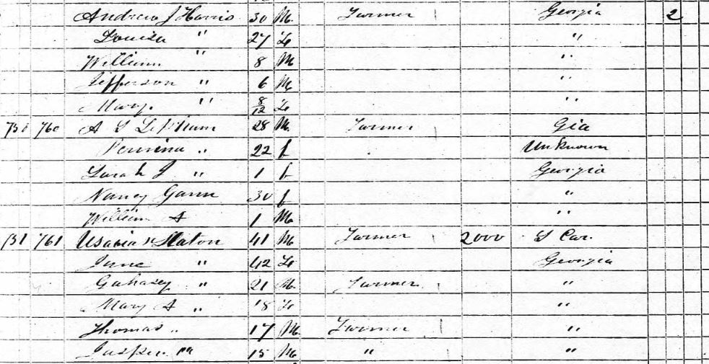
November 1850 Census
Living in the preceding household with the Liphams are Andrew Harris and his wife Louisa Gann Harris (daughter of Nathan Gann). In the next household listed after the Liphams is Usebious Slaton whose sons Gahazi and Thomas marry two other daughters of Nathan Gann.

1860 Fayette County Census
On the 1860 Census we find that Sarah J Gann is listed as the child of Nancy Gann. William Gann is not listed. Nancy has a little farm land.
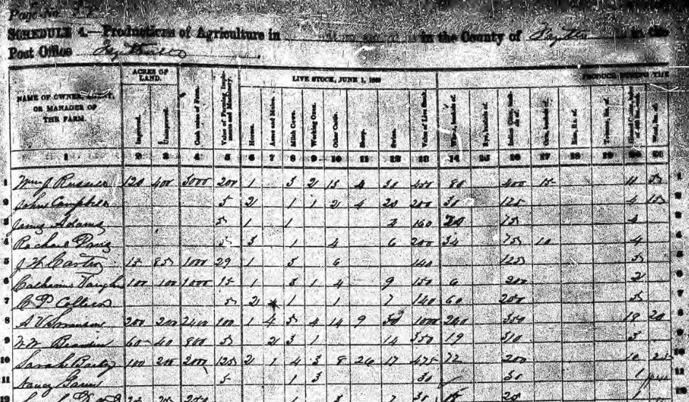

Nancy Gann’s farm has $5 worth of equipment, one milk cow, three working oxen, and $30 worth of livestock.
On 23 November 1869, Sarah J Gann married James Wade Harris.
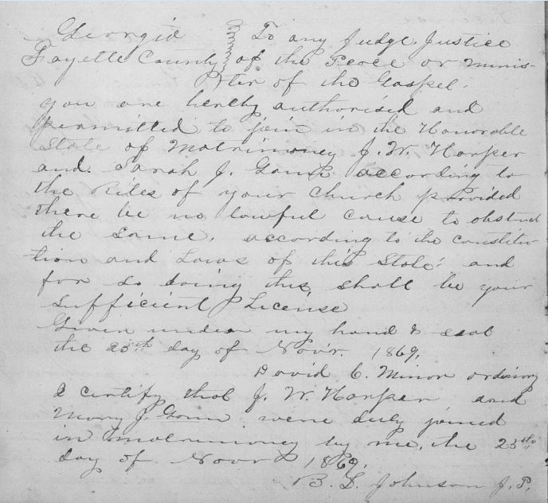
Sarah J. Gann and J.W. Harper Marriage Record

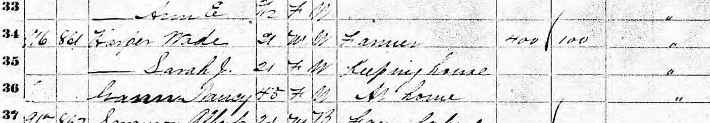
1870 Fayette County Census
Nancy Gann is residing with James Wade Harper and his wife Sarah.
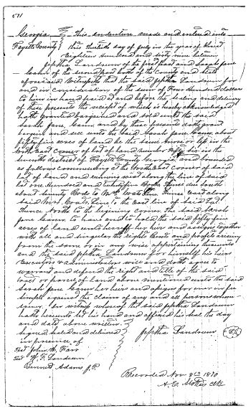
Deed 8November 1870 Sarah J Gann selling property
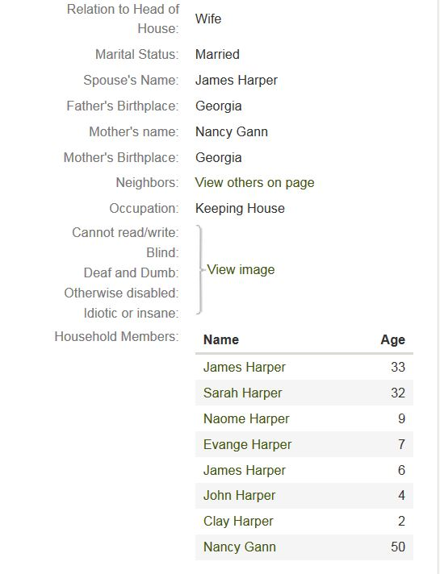

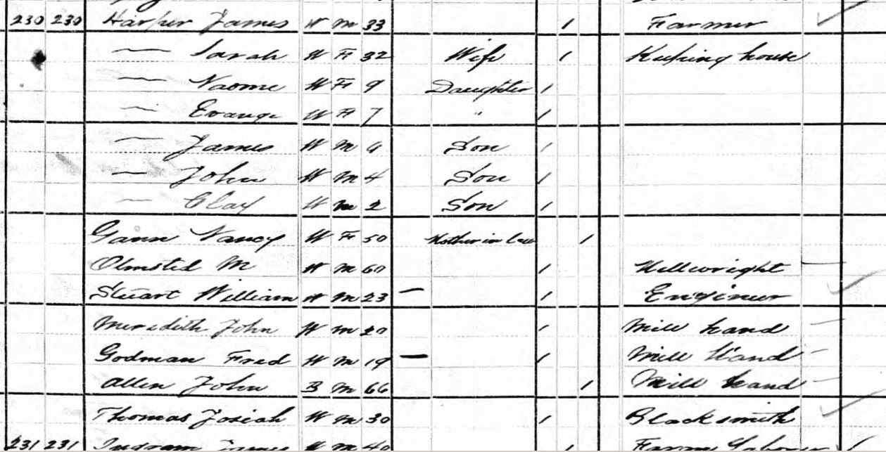
1880 Bastrop County, Texas Census
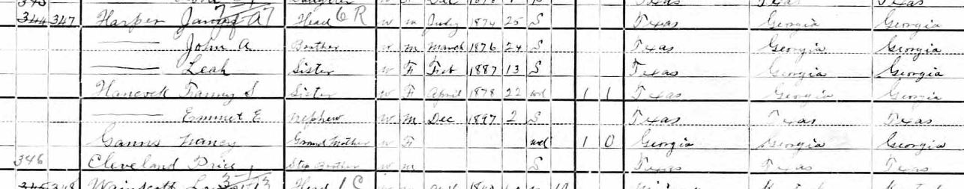
1900 Bastrop County Census
Sarah J Gann died prior to the 1900 Census, however her mother Nancy is still living with James Harper.
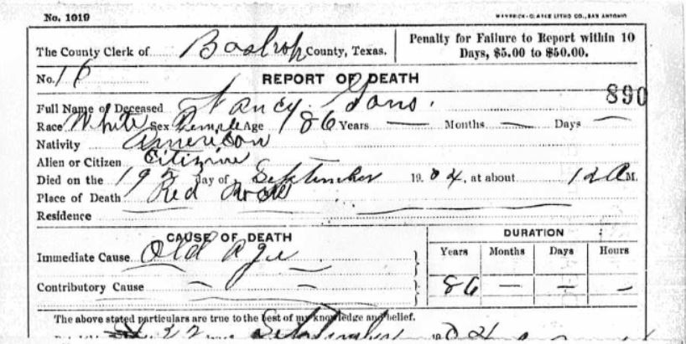
Nancy Lipham Gann’s Death Certificate

Other Deed Information of unknown significance from Fayette County, Georgia

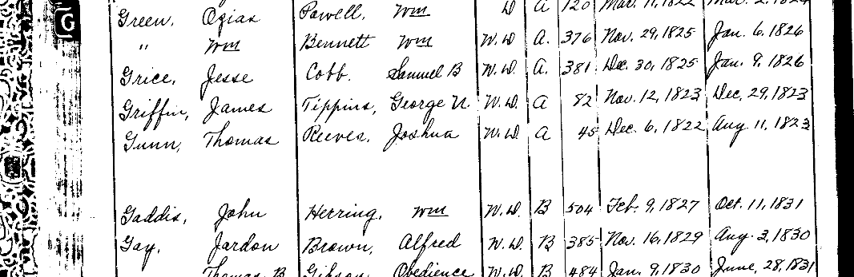
Deed Index Book Excerpt
*See attached .pdf file concerning Thomas Gunn Deed
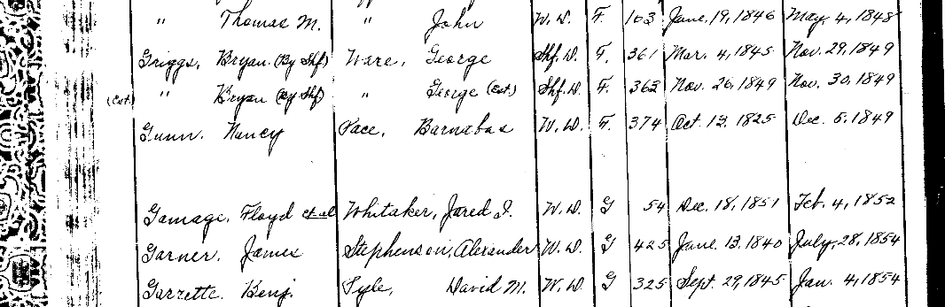
Deed Index Book Excerpt
*See attached .pdf file concerning Nancy Gunn Deed

- SARAH J GANN was born in Fayette County, Georgia about 1848 and died in Bastrop County, Texas in 1900. She married James Wade Harper (1848-1929) on 23 November 1869 in Fayette County, Georgia. They moved from Georgia to Texas in 1873.

Children of SARAH J GANN and James Wade Harper are:

- Naome Harper b. 1871
- Evange Harper b. 1873 d. 1955
- James A Harper b. 1874 d. 1940
- John Appleton Harper b. 1876 d. 1963
- Clay Harper b. 1878
- Fannie S Harper b. 1878 d. 1939
- Leah Harper b. 1887

- WILLIAM A GANN was born to UNKNOWN MALE GANN and Nancy Lipham about 1848 or 1849 in Fayette County, Georgia and died 16 March 1917 in Winston County, Alabama?
Willie did not know his own birthday which is very evident from different records. He joined a Confederate Homeguard Unit in Roanoke, Alabama in 1863. (Possible Homeguard units include Captain Bird Ford’s Company, McClendon’s Company, or Jefferson Faulkner’s Mounted Infantry Company A )
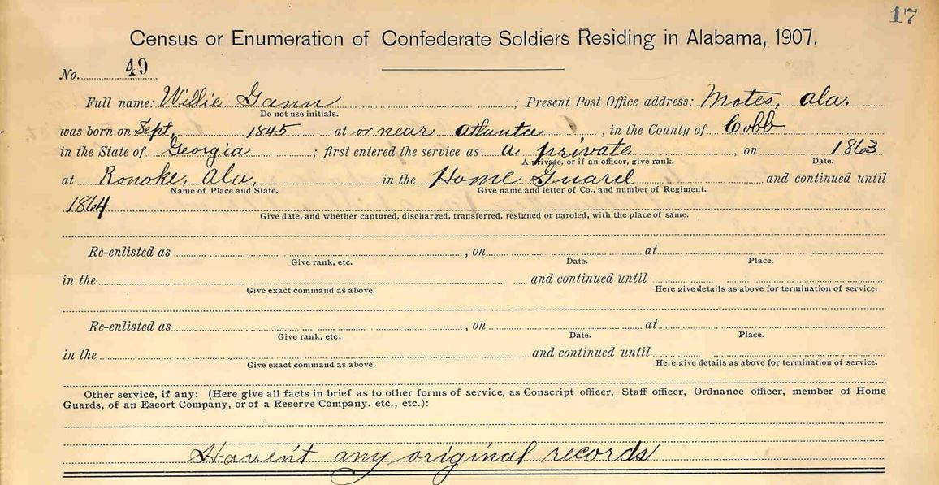
He did not join until 1863 after the war had started. This is likely due to his age. If he had been born on the date listed on the 1904 Winston County Census, then he would have been old enough to be drafted into the regular army.
Willie married about 1865 to Sarah Francis Garrison (1843-1907) daughter of Coleman Harvey Garrison (1811-1860) and Sarah A Wilson (1812-1870). The Garrisons lived somewhere between Wedowee and Roanoke in Randolph County.
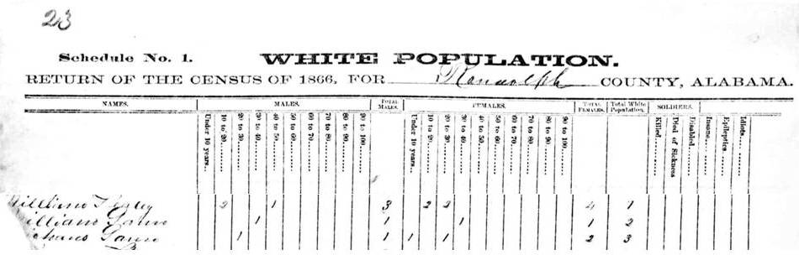
1866 Census of Randolph County
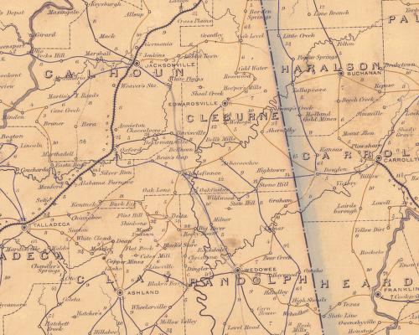
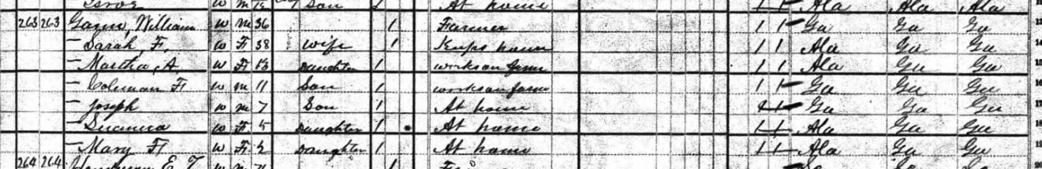
1880 Cleburne County, Alabama Census

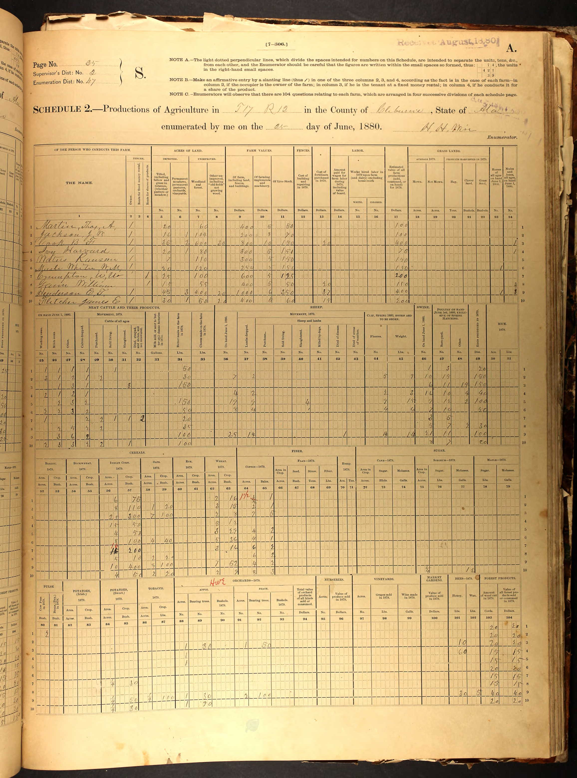
8. William Gann rented land, 15 acres of tilled land, 55 acres of woodland, $400 value of farm, $5 of farming machinery, $50 worth of livestock, $20 of fertilize purchased in 1879, estimated value of all farm production $150. Two milch cows, 5 other cattle, 2 dropped calves, produced 35 lbs of butter in 1879, 5 pigs, seven chickens, two other poultry, 30 dozen eggs produced in 1879.
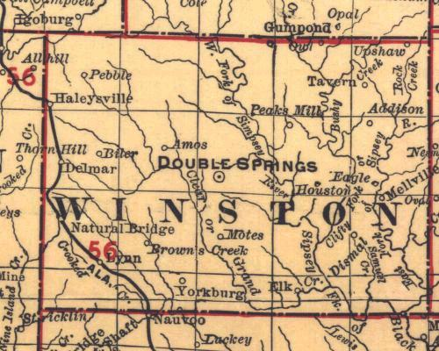
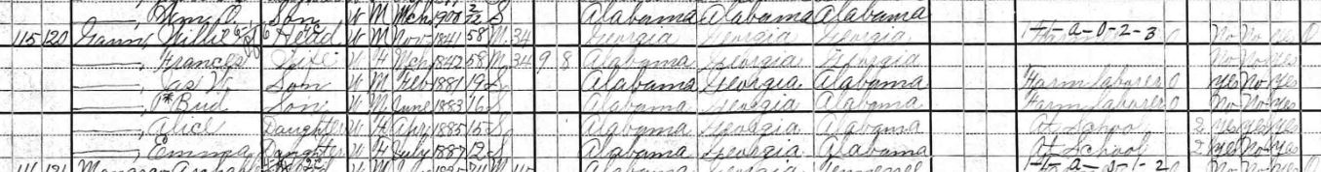
1900 Winston County, Alabama Census
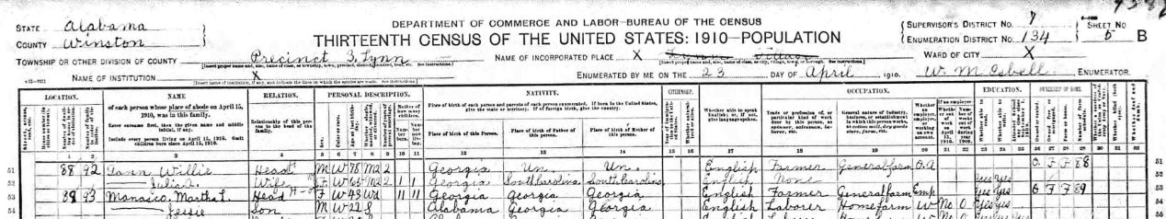
1910 Winston County, Alabama Census

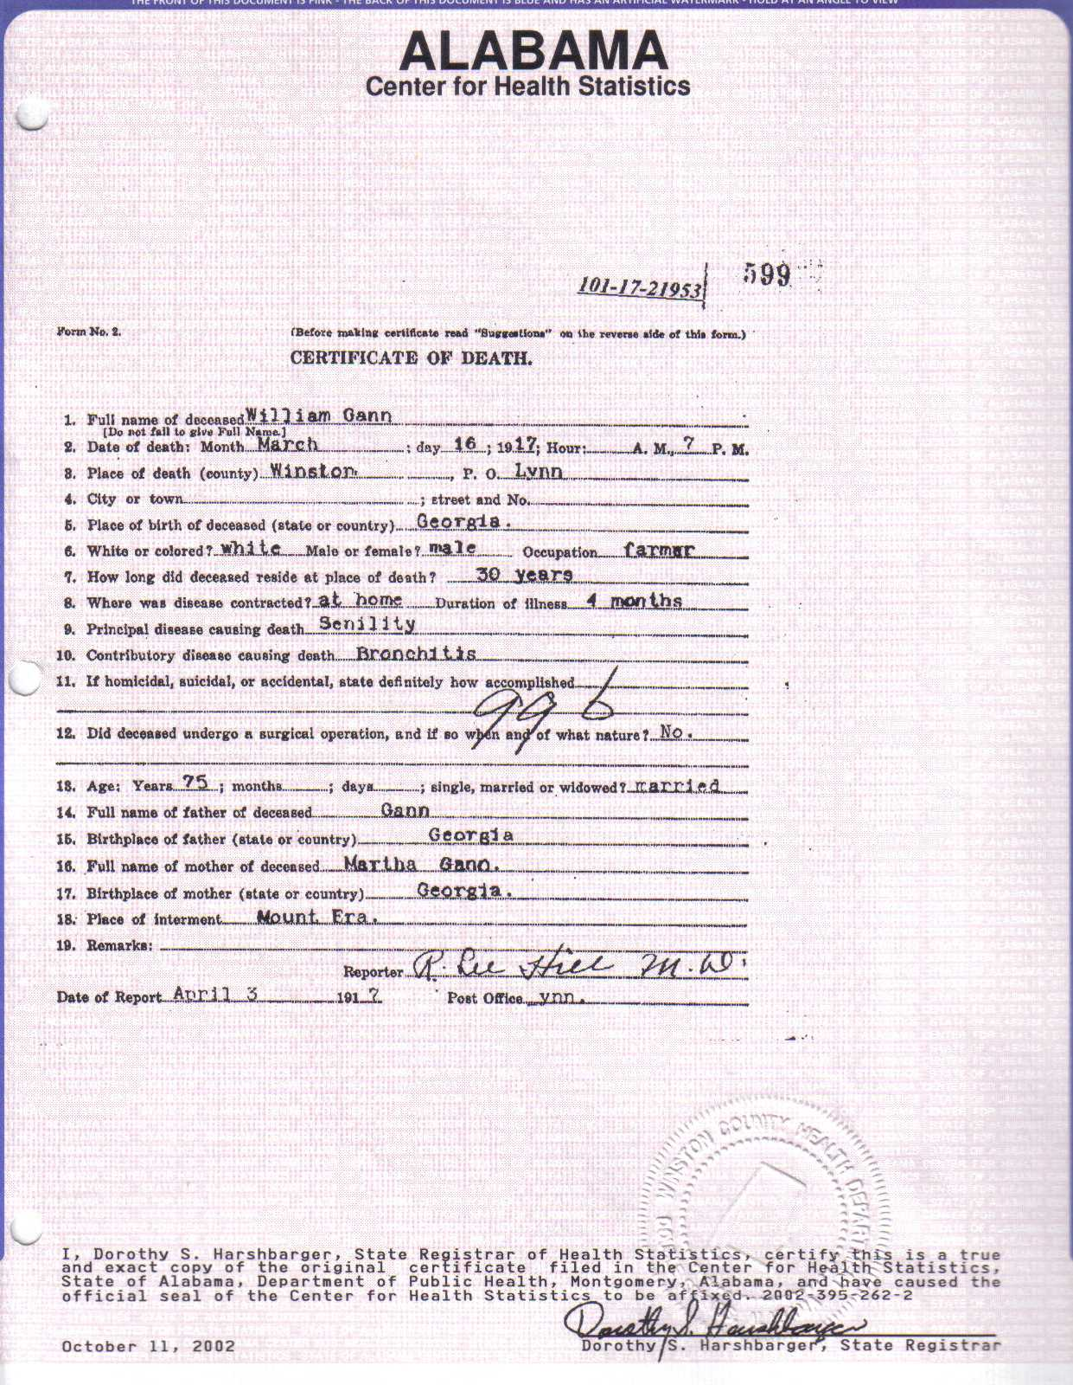

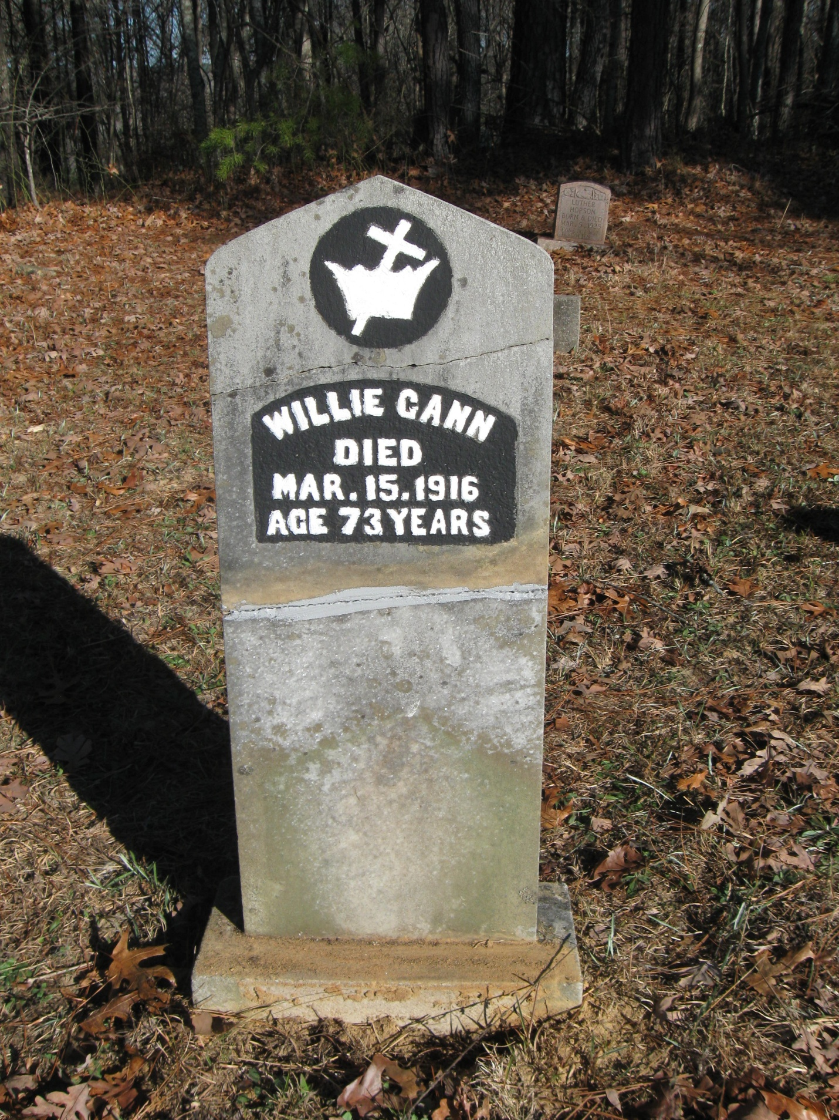
Headstone of William Gann at the Mt. Ararat Cemetery,
near Ashbank in Winston County, Alabama.

- WILLIAM A GANN was born to UNKNOWN MALE GANN and Nancy Lipham? about 1848 or 1849 in Fayette County, Georgia and died 16 March 1917 in Winston County, Alabama. He married Sarah Francis Garrison(1843-1907) in near Roanoke, Fayette County, Alabama around 1865 or 1865. His second wife was Julia A Wilson (b. 1848) on 16 August 1908 in Winston County, Alabama after the death of his first wife Sarah Frances.

Children of WILLIAM A GANN and Sarah Frances Garrison are:

- Martha A Gann b. 1865 d. 1958
- Coleman Franklin Gann b. 1868 d. 1943
- Joseph Malone Gann b. 1873 d. 1960
- Suanna Gann b. 1875 d. 1902
- Mary Frances Gann b. 1878 d. 1903
- James W Gann b. 1881 d. 1903
- David Bud Gann b. 1884 d. 1912
- Alice Gann b. 1885 d. 1903
- Emma Gann b. 1887 d. 1916

------------------------------------------------------------------------------------------------------------------------------------------
There is one more William Gann that I have found that could possibly be my ancestor. He is in the right place and the right age. He is listed living with Francis Gann age 25 in Cobb County, GA on the 1850 Census.
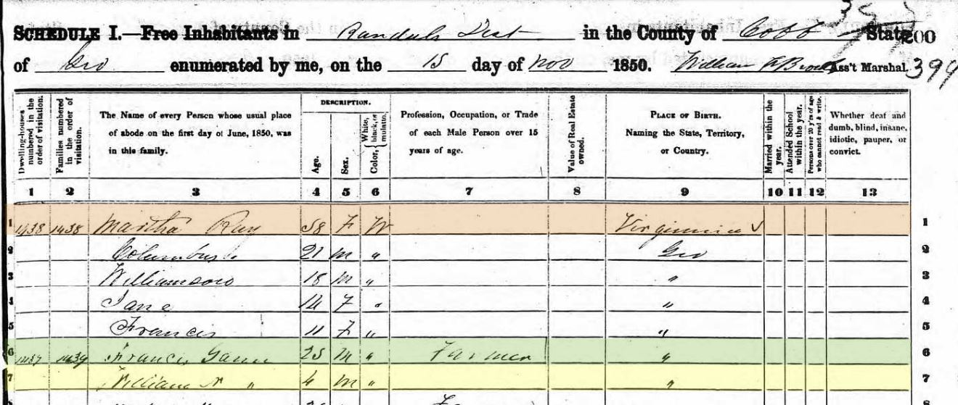
The search for my ancestral Gann line continues…

