Gann Haplogroup
A haplogroup is a major branch on either the maternal or paternal tree of humankind. Haplogroups are associated with early human migrations. Today these can associated with a geographic region or regions.
Ganns in the USA that are descendants of Samuel Gann are members of the R1b haplogroup. The majority of Europeans are members of this haplogroup. You may have noticed on the FTDNA Gann Project page that it shows M-269 as your haplogroup. Both of these statements are true, as the M269 group is a subset of people under the R1b group.
A subclade is a subgrouping in the haplogroups of the human genetic trees. This may be either the Y-chromosome tree or the mitochondrial tree. Subclades are more specific to a location or population group than the major branches (haplogroups).
Here is a depiction of the migration pattern of our haplogroup R1b.
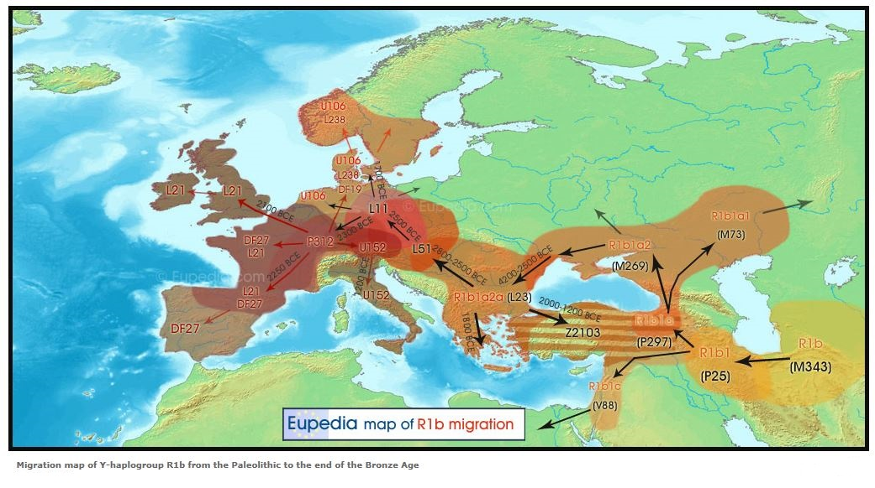
When subclade testing has been performed, we find out that we are members of another group called U-106. Here is a map of the distribution of U106 within Europe.
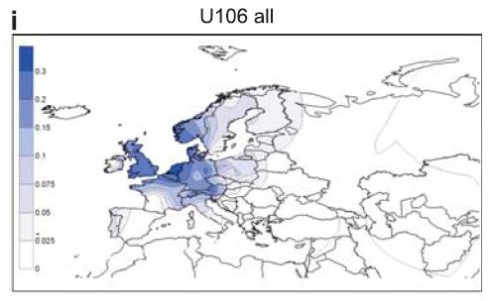
The highest density of U106 is in Belgium, Northern Germany, Denmark, Southern Sweden, Southern Norway, and England.
The most recent testing shows that from S21 or U106, that we come under Z381. And below Z381 we are a very small subset of Z301, FGC8512.

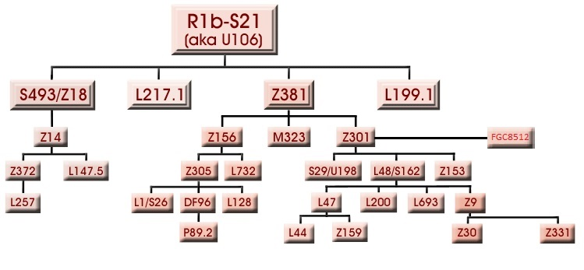
The small subclades of Z301 are still be researched, and have not been placed in the phylogenetic tree yet. (http://www.isogg.org/tree/ISOGG_HapgrpR.html)
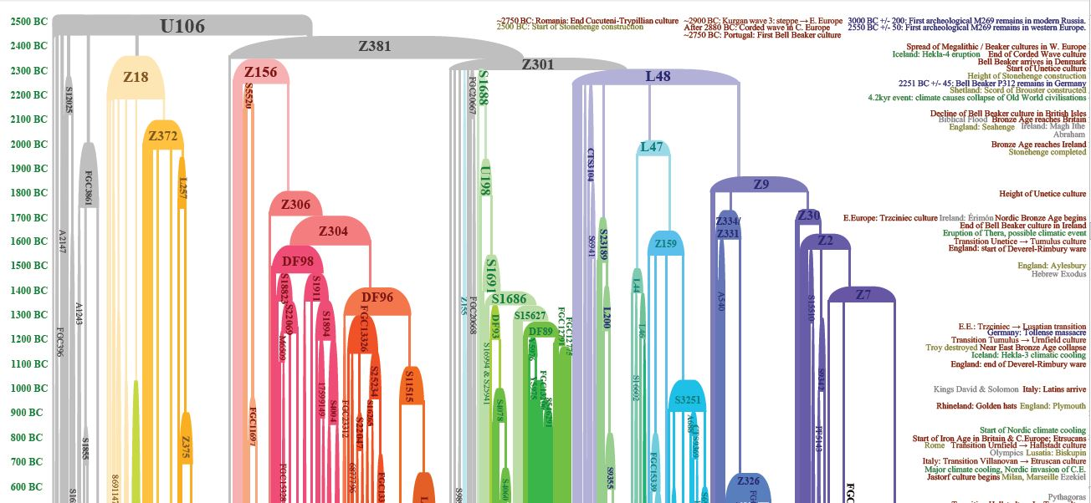

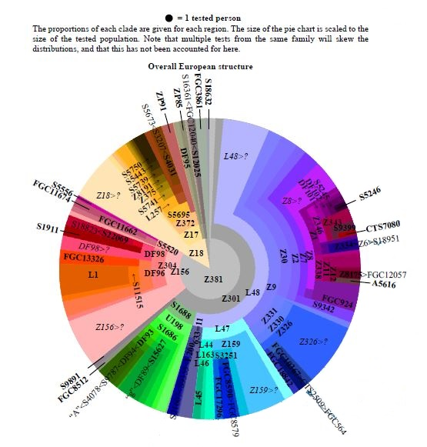

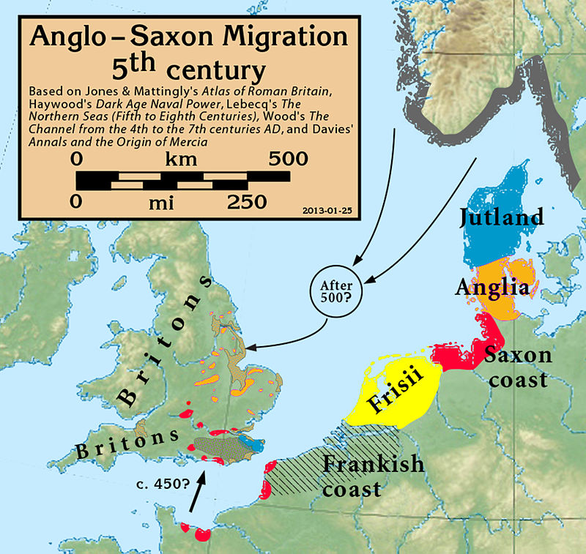

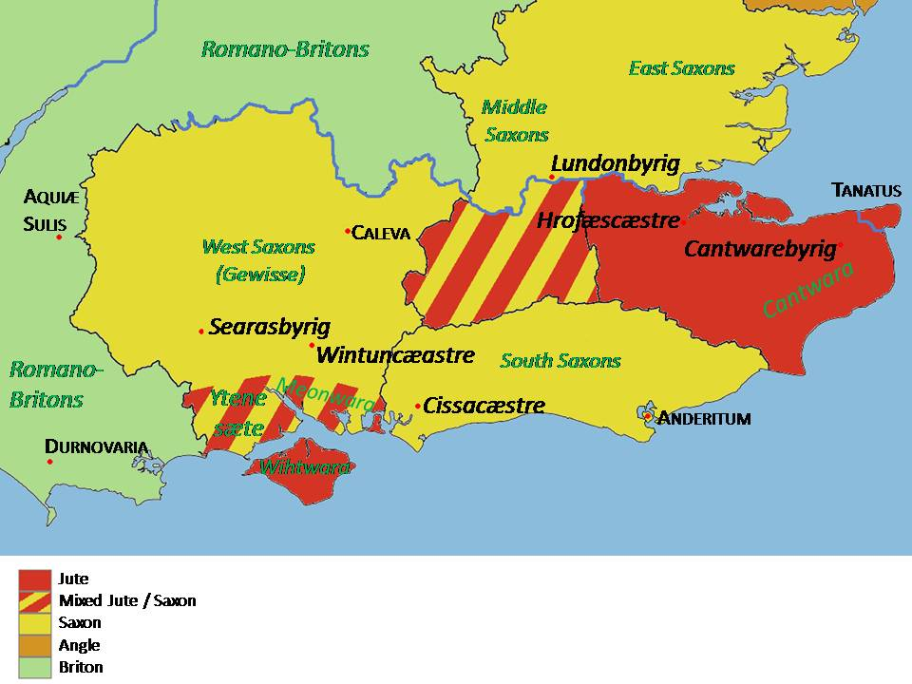

Combining the early DNA history with genealogical data starts to present a picture of very early Gann migration. The first Ganns likely originated in the land of the Germanic tribes of the Saxons and Jutes, and moved to settle in England and Ireland, and later the USA. In Joy Gann Brown’s book “The Ganns: 1200AD-1800AD A Journey of 600 Years and 6000 Miles” she reports on records of Ganns from the Flanders area, which is the area of Northern Belgium. Also identified geographically in England are from Ganns from Lincolnshire and Kent. Historical records and genetic research both seem to agree so far. We have very narrow and unique genetic markers that should make it easier to track in the future. As time goes on and more genetic data is gathered and analyzed, more specific information will be forthcoming on our early origins. MORE TO COME IN THE FUTURE!!

